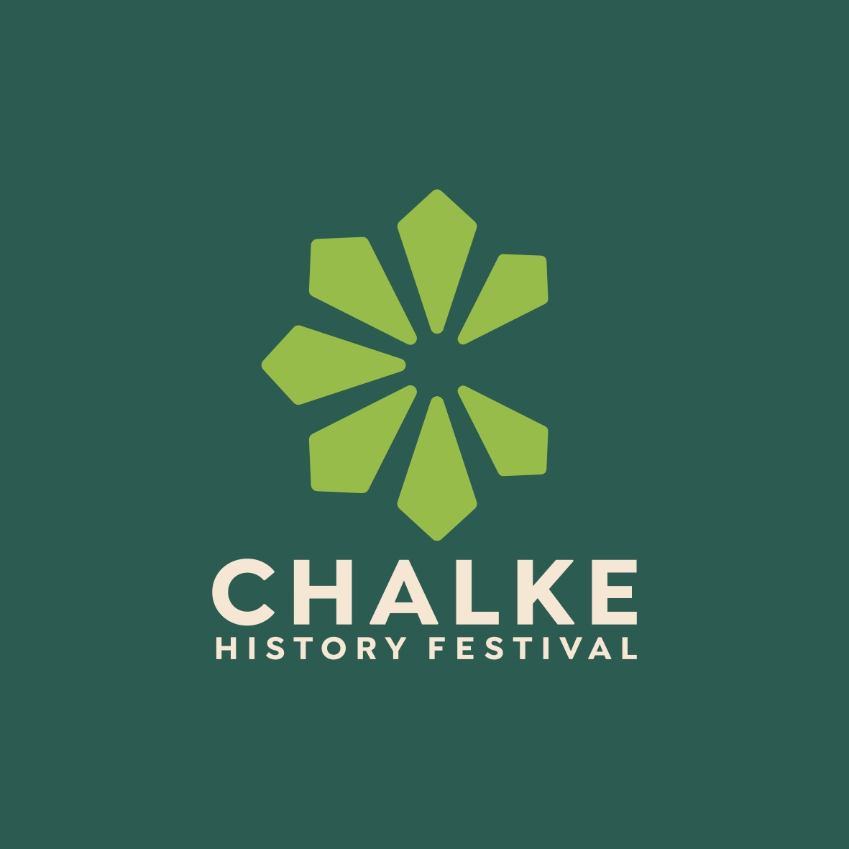

The historical event of the summer!

The Chalke History Festival announces a new name, a new look, and a programme to make your mouth water

Save the dates: 24th-30th June 2024

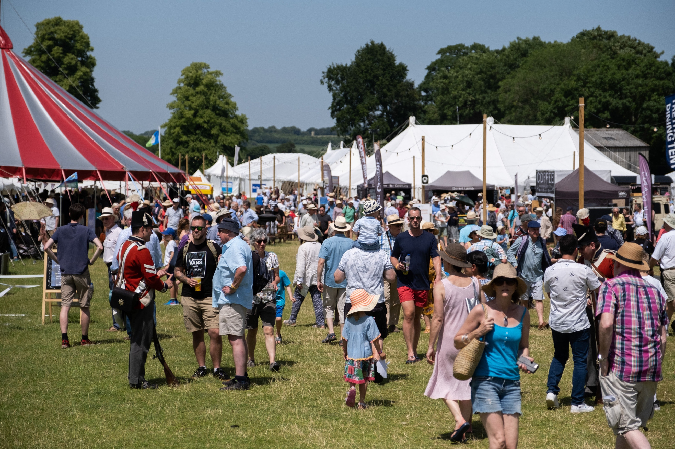
Photo credit: Adam Gichie

The Chalke History Festival - the biggest, most celebrated history festival in the world -will this year run from 24th to 30th June. To mark the start of a whole new chapter for the event it has announced a new name and a new look, with the website and branding being given an eye-catching makeover. Aided by the expertise of leading branding agency BLOOM and celebrated digital media agency Konekt, the festival is set to make a splash in 2024 using a fresh new logo, new social media handles and the new domain name www.chalkefestival.com - all reflecting an exciting moment in the history festival’s life.

History has rarely been more important than now. The Chalke History Festival programme for 2024 will reflect this, dealing with themes and concerns that dominate our current lives. The festival planning team will also be mixing the timings up a little this year, so as to avoid a wall of events all running concurrently, and there will be an increase in the number of panels and discussions. The aim is to provoke more conversation and debate about how the past guides us to the present and helps us prepare for the future. The line-up will show the threads and patterns of history and help those who visit to think about our history in different ways, and also help people to contextualise and make sense of the current rather tumultuous world we live in.

A number of big household names - including James May, The Rest Is History duo Tom Holland and Dominic Sandbrook, Max Hastings, Bettany Hughes, musician and record producer Jakko Jakszyk, and Sathnam Sanghera - have already been signed up as well as a greater number of international speakers and experts.

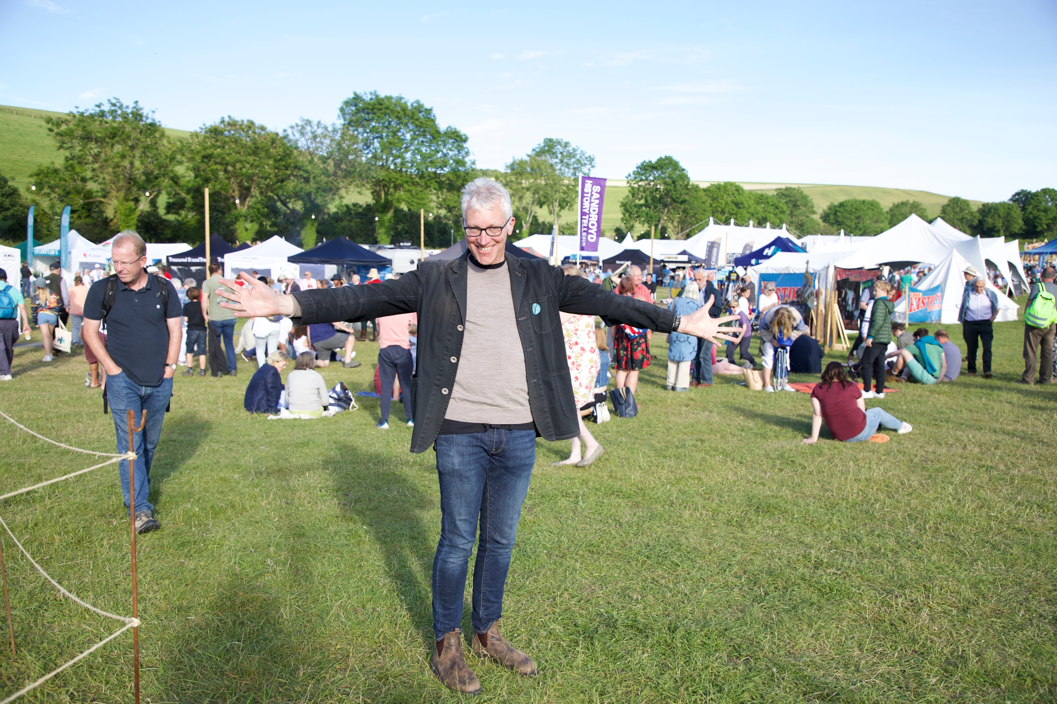
Photo credit: Russell Emm

There will be more performance this year, with no less than eight different acts and performers speaking around the site - every day and throughout the week - from light-hearted yarns through to expert traditional crafts people, and from the Iron Age through to the Second World War. In addition, there will be five main venues for talks and discussions, so there will be a huge amount on offer.

The layout of the site will be slightly different too as the team has given thought to the whole experience of how visitors can view the many events on offer. The main tent will be set-dressed on the stage, the second venue will be a vaudeville-style Spiegel tent and the outdoor stage will be a honeycomb dome design and closer to the hub of the main activities. There will also be more live music, including an ABBA tribute act on the Friday night and a D-Day Dance on the Saturday evening. Each night there will be a different live music act, as well as on the Sunday a five-course lunchtime historical banquet.

News of programme developments will be announced over the coming months and those interested in attending are encouraged to keep checking on the new website and the festival social media channels for all the latest announcements. Tickets will go on general release to the public in April.

Over 200 fascinating talks, given by incredible historians and entitled ‘Chalke Talk’, can be heard on the Chalke History Festival podcast. These talks have been taken from more than a decade of festival appearances.

For further information, please contact Alex Hippisley-Cox on mobile 07921 127077 or email her at alex@ahipcoxpr.co.uk

The Chalke History Festival will take place at Church Bottom, Broad Chalke, Salisbury, Wiltshire, SP5 5DP. For more details about the festival, please visit the recently-relaunched website at www.chalkefestival.com Follow all the news on X @Chalke Festival and Instagram at @chalkehistoryfestival and on Facebook.

Notes to editors

Helping to take the festival forwards into the future are two key new members of the team. Tom Wright has joined as Managing Director and Roz Skellorn is now Marketing Director. Tom is a Board Member of both the National Museum of the Royal Navy and Leeds Castle and is also Chair of The Imperial War Museum Development Trust. Roz was formerly Marketing Communications Manager at The Tank Museum in Dorset, where she worked for a decade, and was part of the team behind the hugely popular TANKFEST. Joint Programme Directors Charlotte Casella and Laura Bailey have been promoted to the Executive Board, with James Holland overseeing the festival team as Co-Founder and Creative Director.

About the Chalke History Festival

Attracting the finest and most distinguished historians, academics, leading thinkers, and writers from the UK and abroad, the Chalke History Festival is now firmly established as one of the must-attend events of the festival summer. Taking place on a 70-acre farm, in the heart of the Wessex countryside just outside Salisbury in Wiltshire, it blends inspiring literary talks, discussions and panels with eye-catching and entertaining living history and historical experiences.

