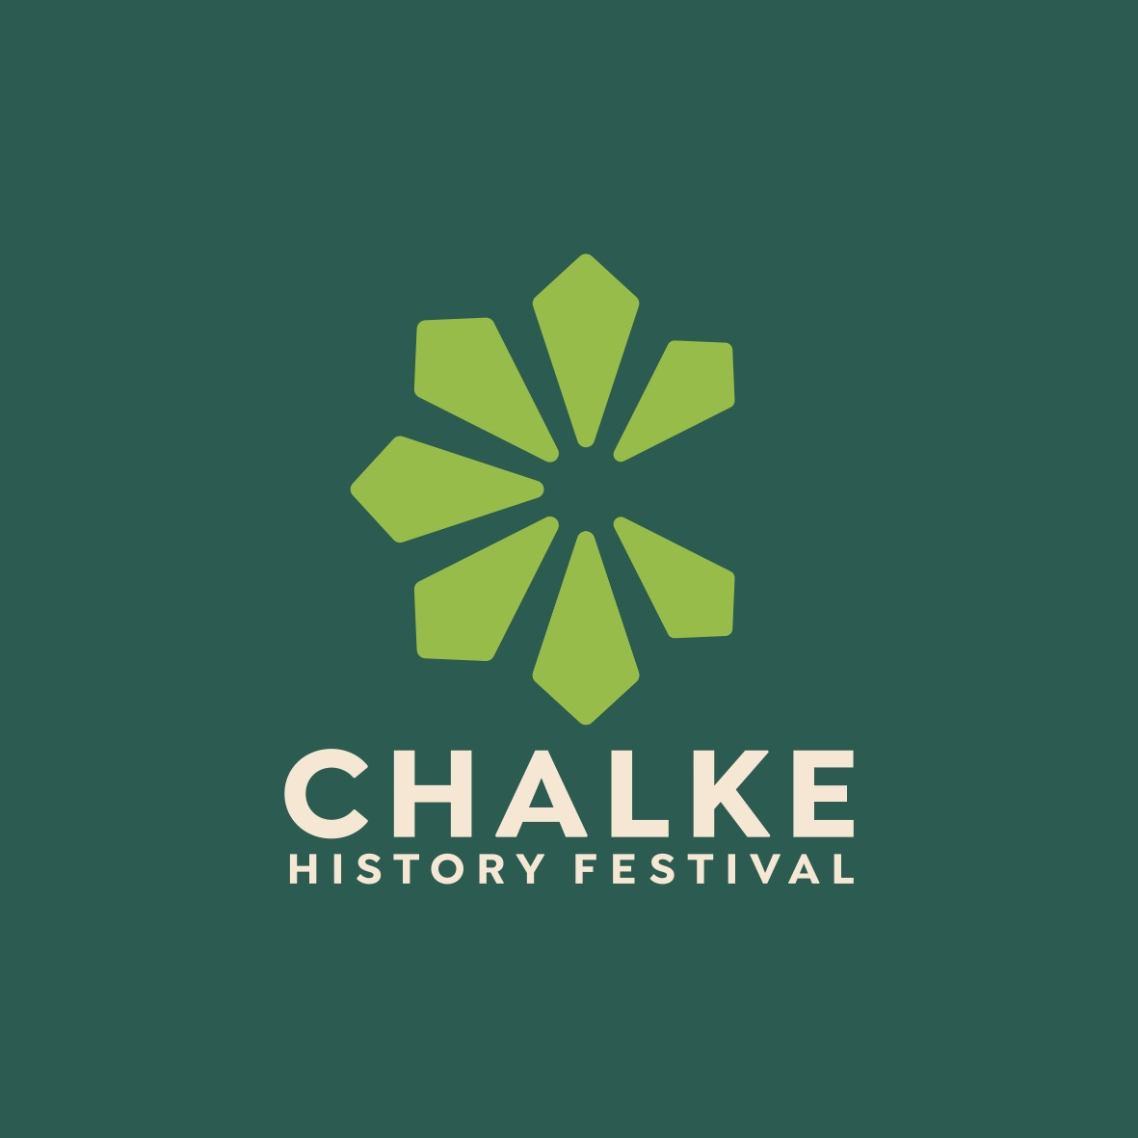

Chalke History Festival - 24th-30th June

New big names added to the programme schedule

Early bird and discounted student tickets now on sale, plus camping and glamping open for booking

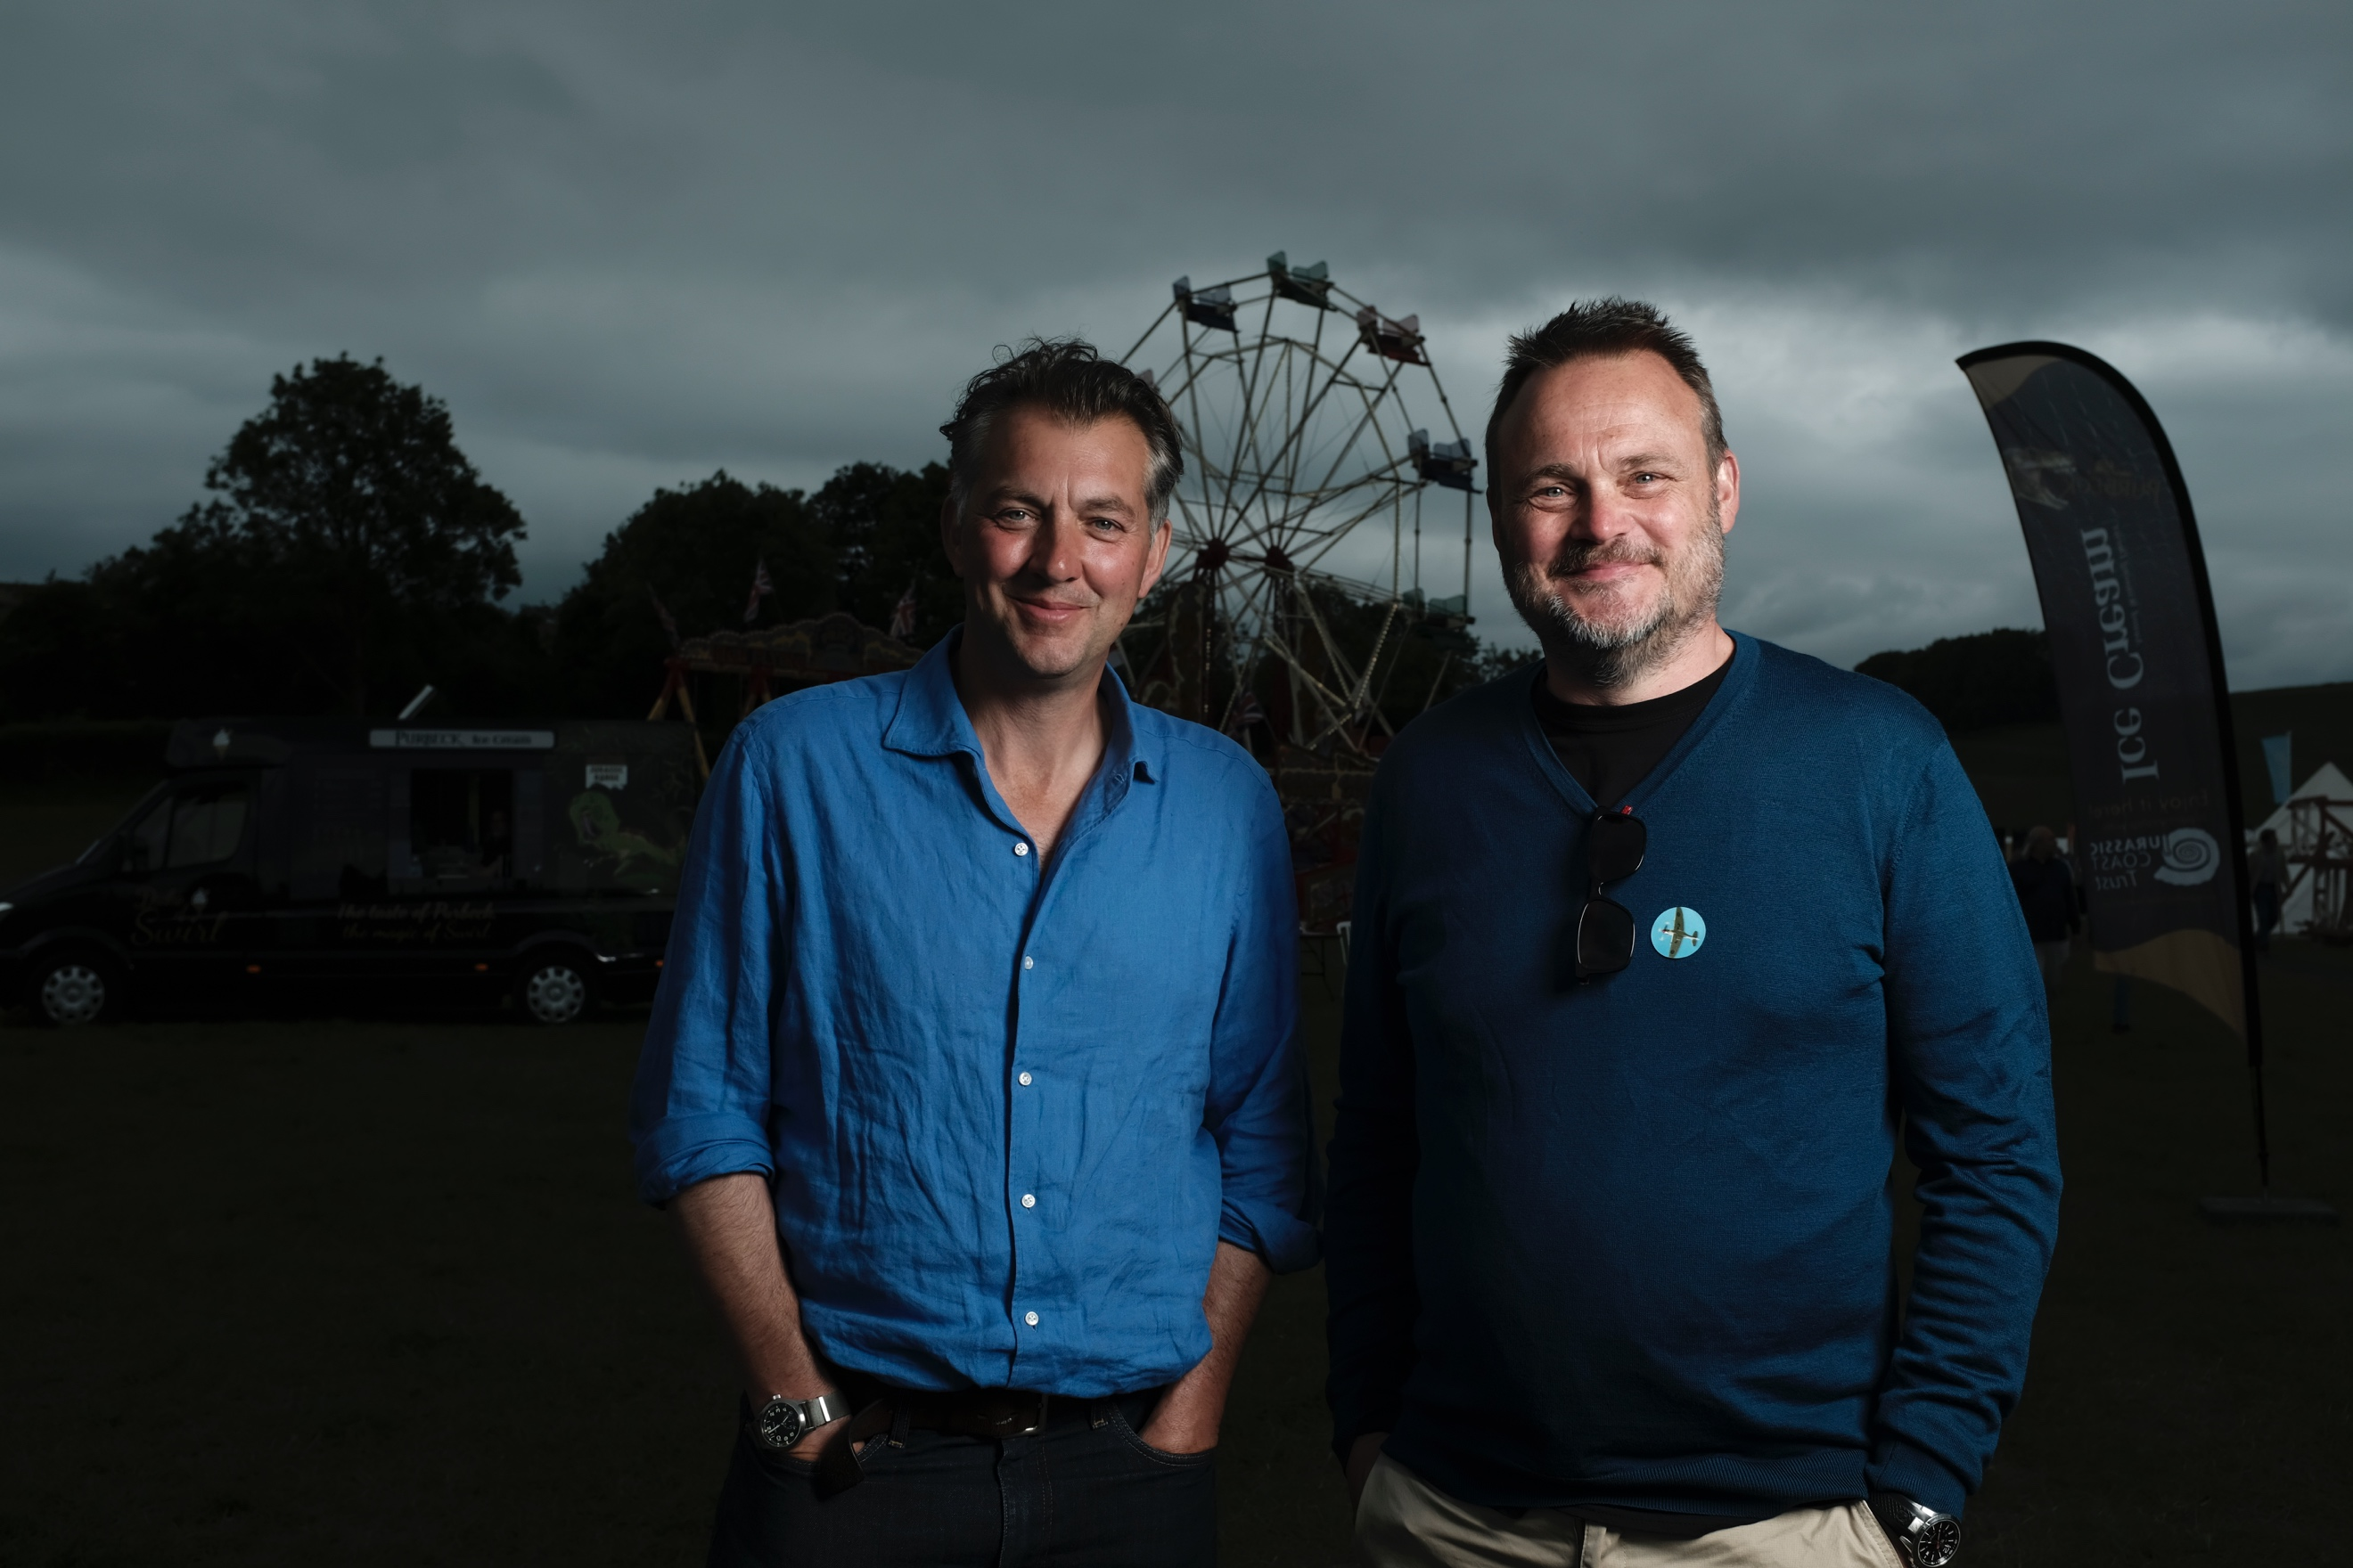
We Have Ways of Making You Talk podcasters James Holland and Al Murray Photo credit: Andrew Chorley

Over the past decade or so, the Chalke History Festival has firmly established itself as one of the must-attend events of the year, with its mixture of talks, performance, living history and all the elements that the best English summer festivals should have: eye-catching tents, delicious food and drink, camping under the stars and an absolutely magical atmosphere. This year's festival promises to be the biggest and best one yet, with a diverse range of activities and experiences that will appeal to both history buffs and casual visitors alike.

In a year that marks the 80th anniversary since D-Day, the team behind the festival is keen to shift the dial and make it an even more dynamic hub for the very best, most inspiring, thought-provoking and intellectually challenging thinking about the past. The aim is to bring together the most passionate minds in academic historical investigation and debate. By re-examining history through fresh perspectives, and by re-living history through its sights, sounds, challenges and experiences, the hope is that visitors will draw inspiration, by reminding themselves of their origins, enlightening the present and the possibilities of the future.

Details of this year’s Chalke History Festival are gradually being revealed. If history podcasts are your bag, then you are in for a treat this year as two of the UK’s most successful programmes will be recorded in front of a live audience. Podcast royalty Tom Holland and Dominic Sandbrook will be bringing The Rest is History - the most downloaded history podcast in the world, and the top history podcast in the UK as well as the US - to the stunning setting of Church Bottom where they will be sharing their incredible historical knowledge with their usual wit and camaraderie. Furthermore, World War Two aficionados James Holland and Al Murray, will be hosting an episode of their incredibly popular and entertaining We Have Ways of Making You Talk podcast with their usual humour, expert knowledge of the subject and ability to disappear down an historical rabbit hole or two along the way!

The Chalke History Festival is known for its show-stopping arena displays, and this year will be no exception. Historic Equitation - a team of historical interpreters and equestrians led by renowned horseman, Dominic Sewell - will be demonstrating the social, economic and military importance of horses throughout history, from the rise of the mounted knight to the spectacular horsemanship of the 17th century. They will be at the festival all week and delivering a show stopping display in the arena on the Saturday and Sunday.

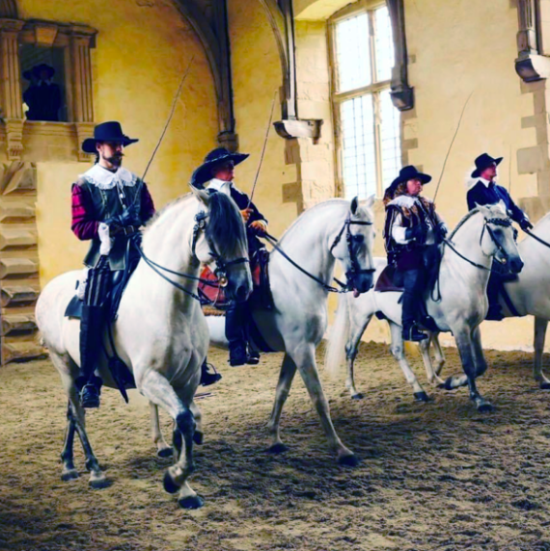
Historic Equitation

Throughout the week, renowned historians and scholars will share their expertise on a variety of topics, providing fascinating insights into many different periods of history. Journalist and co-presenter of the hugely popular TV series The Grand Tour James May will be making his debut at the Chalke History Festival this summer and will be speaking about his favourite subject, cars. Award-winning historian and broadcaster Bettany Hughes will be returning to talk about the Seven Wonders of the Ancient World and, also appearing for the first time, will be the legendary writer, actor, comedian and TV presenter Michael Palin who will be discussing his biography of his great-uncle Harry whose life was tragically taken in the First World War. Plus, acclaimed journalist, broadcaster and President of the School of Oriental and African Studies Zeinab Badawi will be talking about her new book on the history of Africa.

Another new addition to the performance programme is Rattlebox Theatre, who will be enchanting audiences with their puppetry and storytelling every day from Tuesday to Sunday. Their small but perfectly formed adaptation of the Anglo-Saxon epic Beowulf will tell the epic tale through engaging storytelling, beautifully made puppets, and an evocative live soundtrack from early music maestro Steve Tyler. The ever-popular actor and raconteur Adam Schuch-des Forges will also be introducing visitors to the most remarkable officer they’ve never heard of - Major BANGER King - and sharing incredible tales of the 2nd Battalion of the East Yorkshire Regiment as they train for D-Day, fight their way into the Norman Countryside, and face countless insurmountable odds.

For the first time this year, early bird weekly tickets - which give a reduced rate if bought for the whole seven days - have just gone on sale. Booking for camping (for those who wish to bring their own tent or motorhome), and glamping (for those who prefer a little more comfort), is also now available via the festival’s new website. Another first for 2024 sees students being able to purchase half-price weekly tickets, with a further reduction on the price for camping as well.

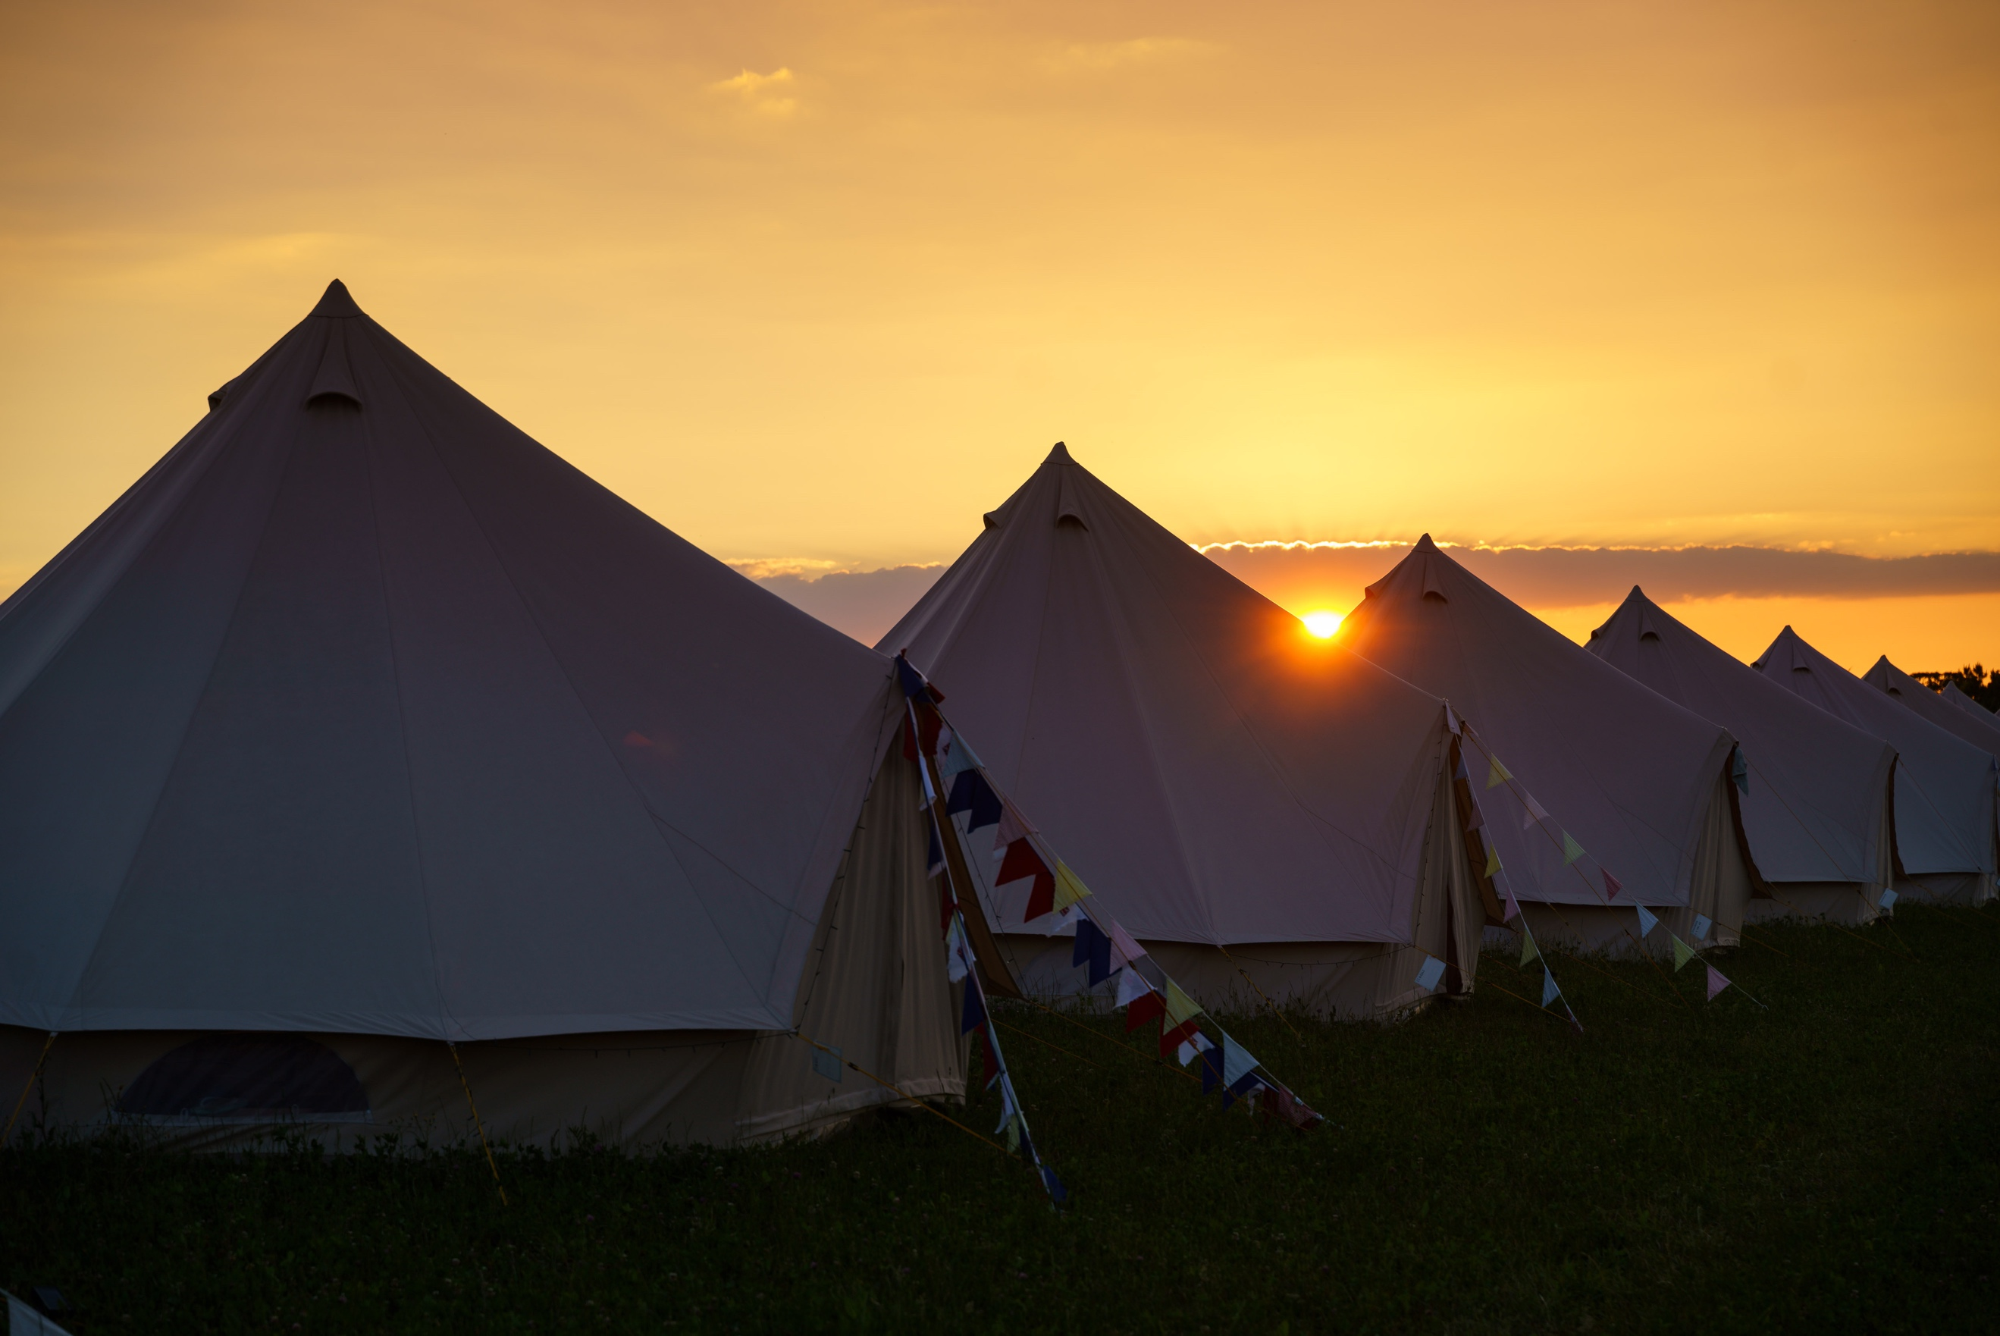
Camping and glamping at the Chalke History Festival Photo credit: Ash Mills

Volunteers play a vital role in the success of the festival and the organisers are always on the lookout for enthusiastic individuals to join the team. The application process is now open via the website.

For further information, please contact Alex Hippisley-Cox on mobile 07921 127077 or email her at alex@ahipcoxpr.co.uk

The Chalke History Festival will take place at Church Bottom, Broad Chalke, Salisbury, Wiltshire, SP5 5DP. For more details about the festival, please visit the recently relaunched website at www.chalkefestival.com Follow all the news on X at @ChalkeFestival, on Instagram at @chalkehistoryfestival and on Facebook.

About the Chalke History Festival

Attracting the finest and most distinguished historians, academics, leading thinkers, and writers from the UK and abroad, the Chalke History Festival is now firmly established as one of the must-attend events of the festival summer. Taking place on a 70-acre farm, in the heart of the Wessex countryside just outside Salisbury in Wiltshire, it blends inspiring literary talks, discussions and panels with eye-catching and entertaining living history and historical experiences.

