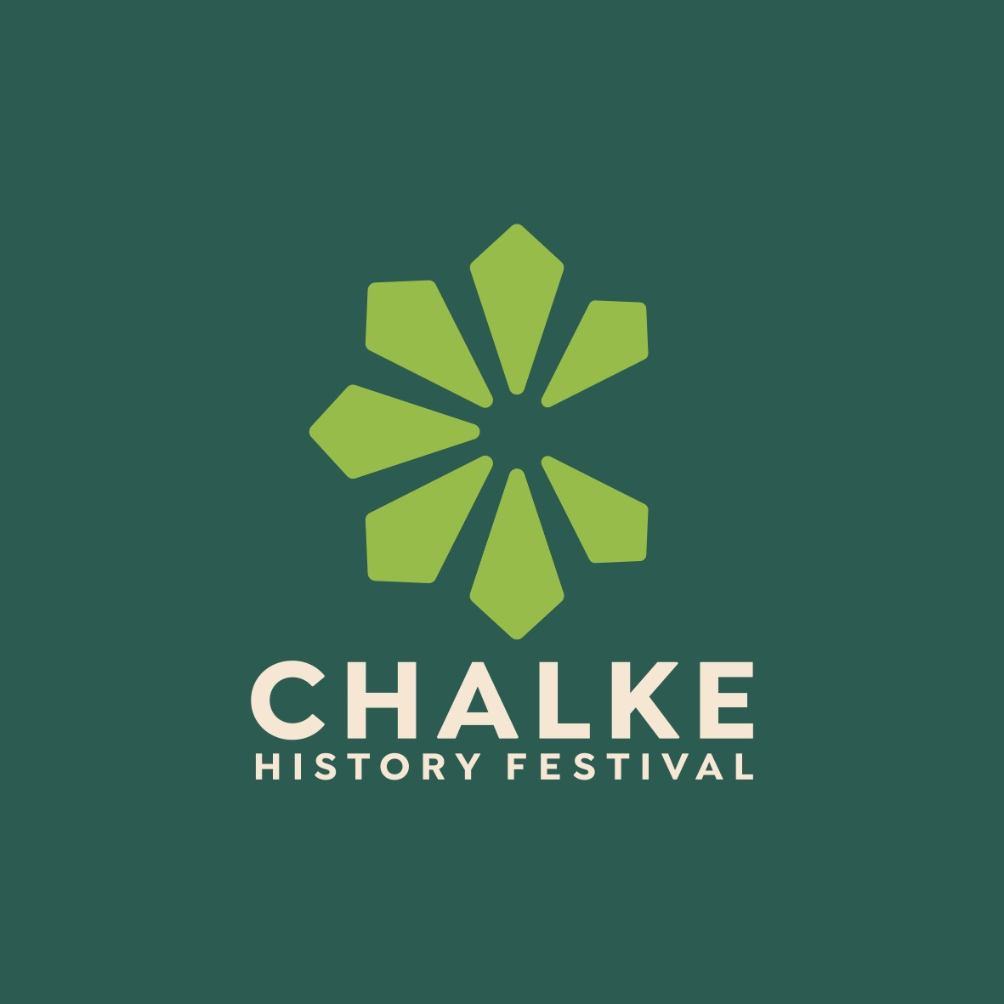

Immerse yourself in the UK’s largest and most popular history festival
from 24th-30th June 2024

Further VIP names and leading thinkers added to programme, three days of schools’ activities announced, and Saturday night party returns

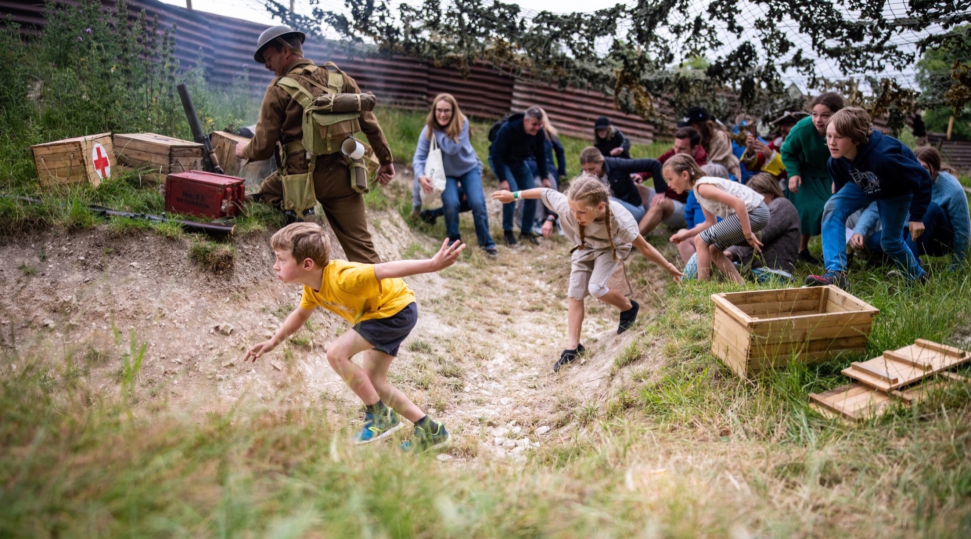
School children being taken through The Trench at the Chalke History Festival Photo credit: Martin Cook

This coming year is going to be historic in a number of ways. Not only does it mark the 80th anniversary of D-Day, and the largest amphibious invasion in military history during the Second World War, but it will also bear witness to a truly remarkable milestone in human history. In 2024, over four billion people – more than half of the world’s population across more than 40 countries – will go to the polls and the global political landscape could be profoundly changed forever.

At the Chalke History Festival, these important topics and more will be discussed by history buffs and curious minds alike when thousands will meet up in Broad Chalke, usually a quiet corner of the Wessex countryside, to experience an unforgettable journey through time. Over the course of one week, a huge range of talks led by 170 renowned historians, authors, and experts - covering a vast spectrum of historical topics, from ancient civilizations to modern events - will take place, and visitors will get the chance to hear from, and pose questions to, some of the country’s leading thinkers.

It goes without saying that history is the foundation upon which our grasp of science, philosophy, economics and every facet of human understanding rests. This year at the festival, as we navigate our complex world, there will be more discussion about big themes than ever before. In one of the highlights of the week, and on the topic of science and innovation, Sebastian Faulks, Adam Rutherford and Rebecca Wragg Sykes will be debating the question of genetic mutation and what it is to be human. When it comes to international conflict, few people know more about the subject than the BBC’s Security Correspondent Frank Gardner who will be talking about his life reporting on headline-making incidents from all over the world. Plus, attending the festival for the first time, will be members of The Alphen Group, a network of leading strategic thinkers from Europe and the United States working to consider the future of the trans-Atlantic relationship and European security and defence.

There are also some lighter subjects adding their weight to the programme. The lead guitarist of King Crimson Jakko Jakszyk will not only be discussing the history of the electric guitar but also playing on stage and demonstrating differing styles as he does so. Feargal Sharkey, best known as the lead vocalist of The Undertones in the 1970s, is amongst the line-up on Wednesday’s Chalke Day when he’ll be sharing his knowledge of chalk streams and his opinions about the environment. And, in the year when Paris will play host to the greatest sporting event in the world, Philip Mansel will be talking about Versailles and The Olympics.

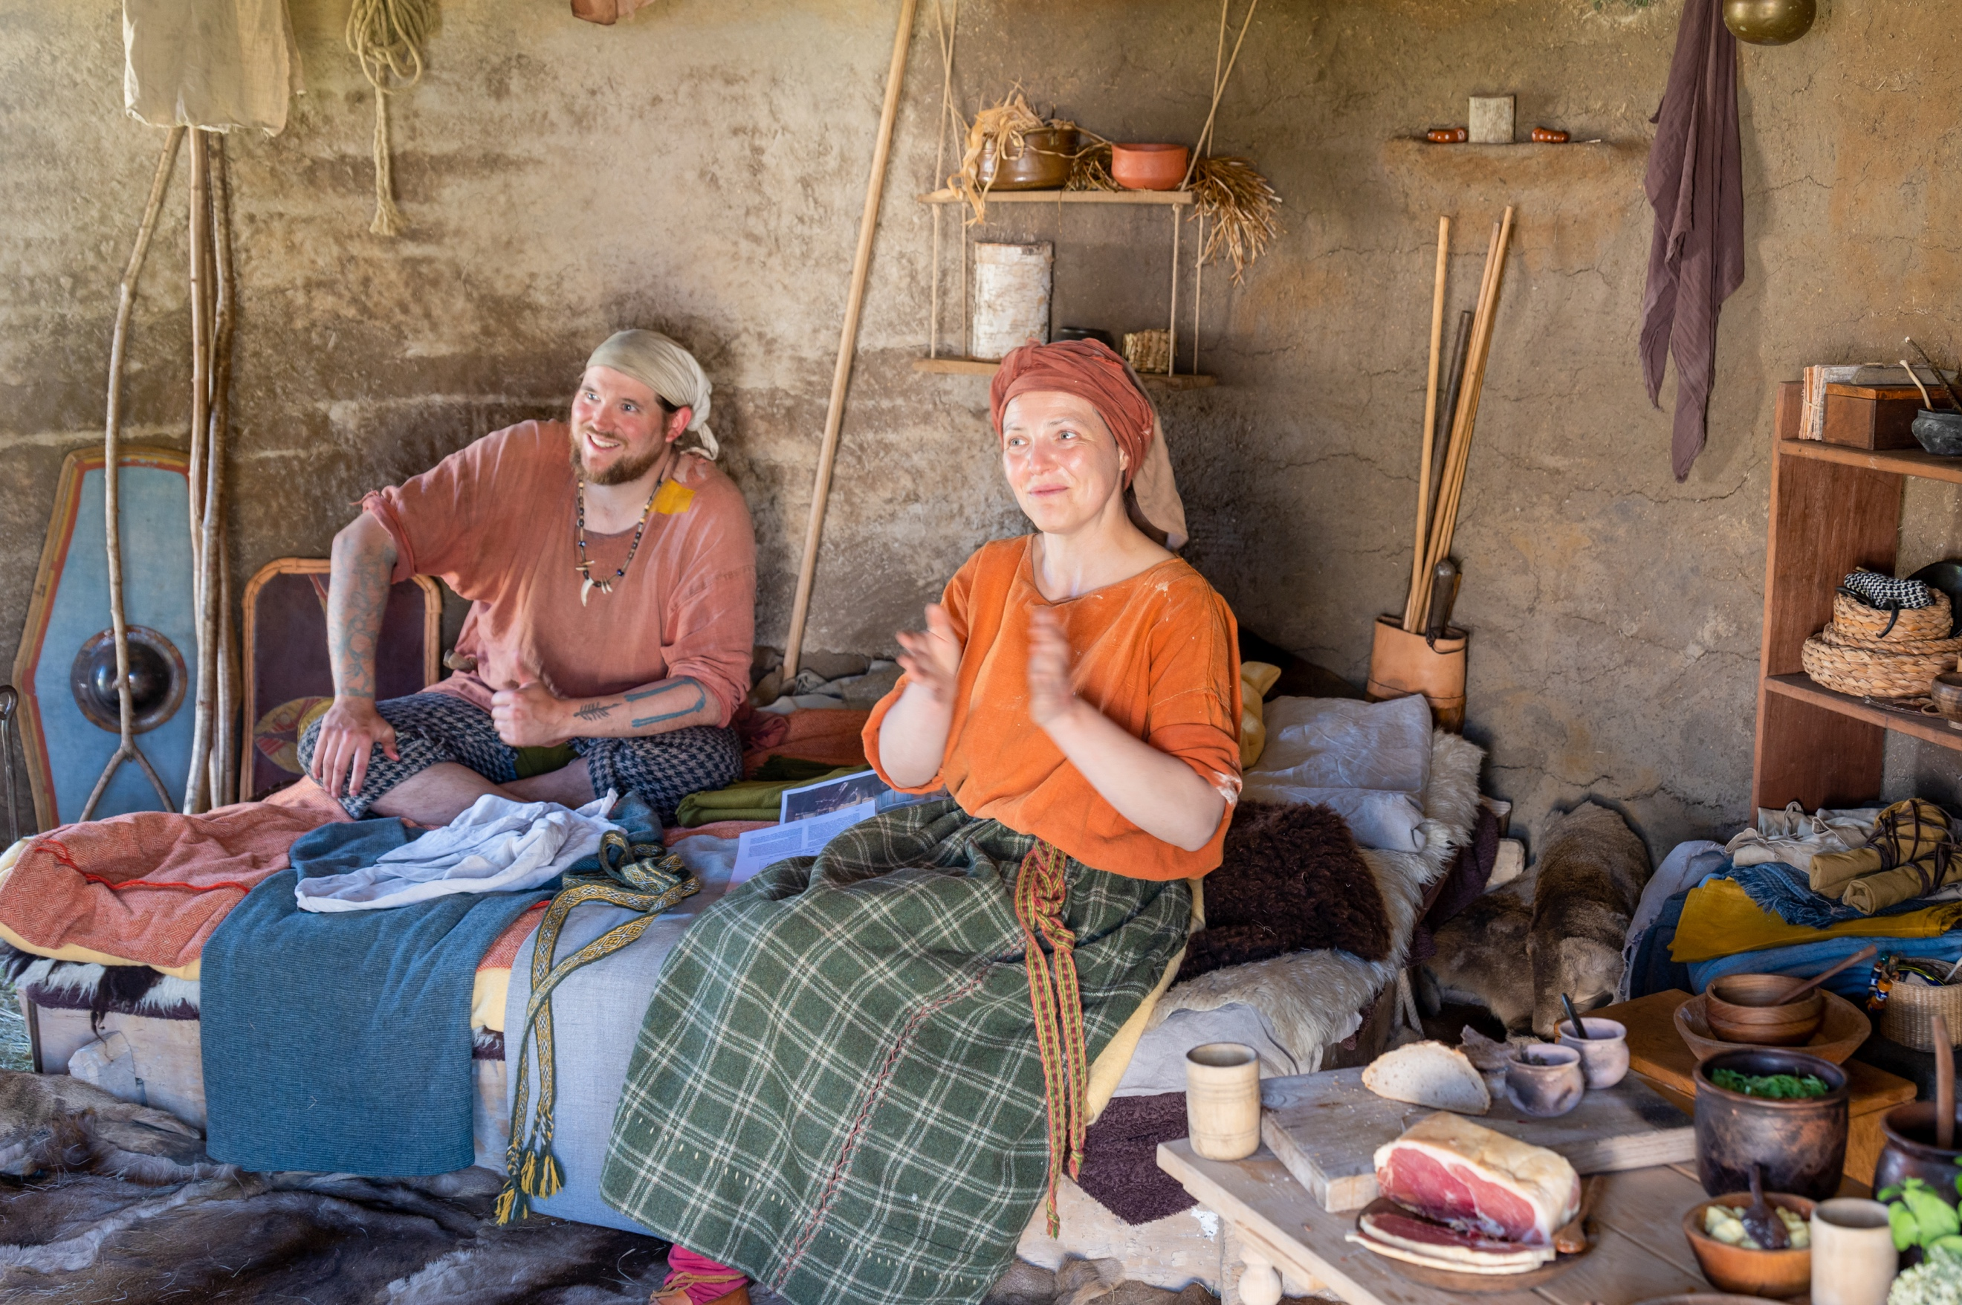
Inside the Iron Age round house at the Chalke History Festival Photo credit: Martin Cook

Interactive living history experiences and performances are right at the heart of the Chalke History Festival. There will be a huge range of activities on offer this year, with visitors able to immerse themselves in different eras, from mastering culinary arts to discovering up close the extraordinary skills of the 17th Century sailmaker. Part of the programme for the first time this summer will be Autojeu Theatre, with their signature brand of physically comic storytelling. Created by the team behind the off-Broadway
5-star hit Beowulf, ‘One Man King Arthur’ will be performed on the Tuesday and Wednesday. Furthermore, a group of extraordinarily skilled craftspeople will be remaking history by recreating the burial chamber and some of the burial goods discovered by archaeologists in Prittlewell, near Southend-on-Sea, in 2003. This is an absolutely unique opportunity to see heritage crafts in action and to discover the historical insights that practical craftsmanship can bring.
With over 18,000 children having visited the festival since its launch, the newly-sponsored by Rathbones Chalke Festival for Schools makes a major contribution to history education and brings the subject alive in new and exciting ways. Over three days, and featuring a wide range of curriculum-based subjects, pupils are given the chance to experience the sights, sounds and smells of history through a programme of interactive and immersive activities. Monday 24th June is for Years 10, 11 and 12, Tuesday 25th June is for Years 6,7,8 and 9, and Wednesday 26th is SEND day, which is open to all ages and which provides a programme that is less structured and takes place in a quieter environment. Topics and themes for this year include The French Revolution, The History of Pies, Tudor Women, Sword Smelting, The Rise of The Mounted Knight and The History of Infectious Disease.

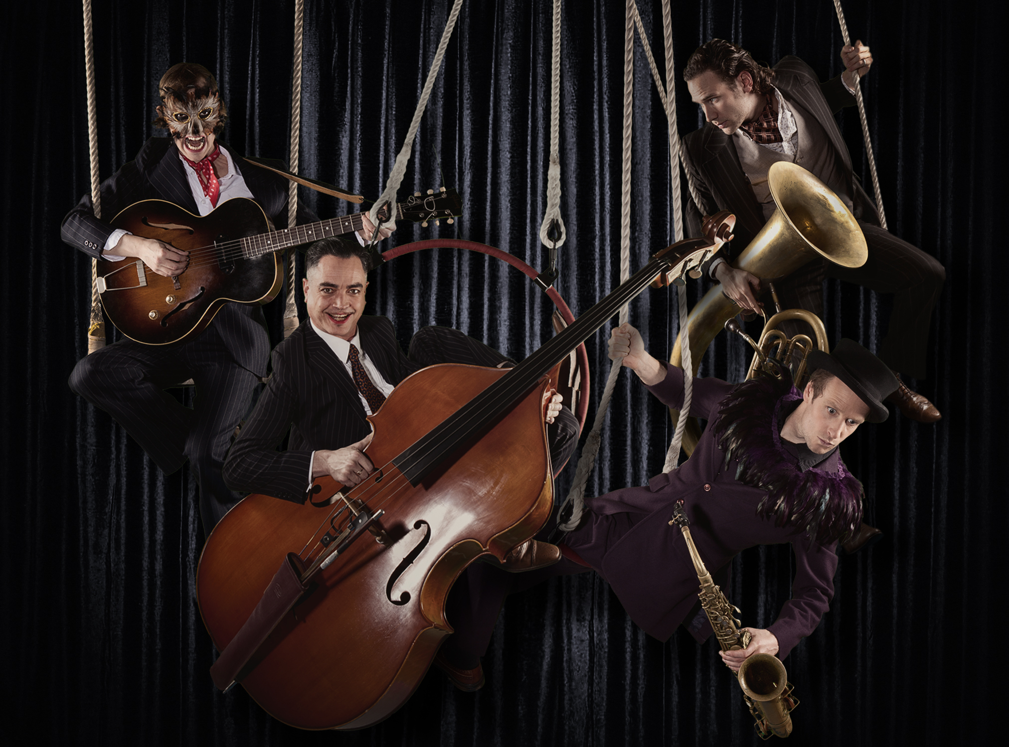
The Swing Ninjas

2024 sees the return of the hugely popular Saturday Night Party at the festival. Visitors should get ready for the raucous sounds of the swing age at the D-Day Dance, which will take place in the new, stunning Spiegel tent and will feature The Swing Ninjas. Blending vocal harmonies with a mix of New Orleans’ swing and vintage UK jazz, the group brings an authentic, up-to-date approach to the sound of a 1930s band. Also getting everyone on their feet that night will be The Polka Dots who will be bringing the swinging sounds of the 30s, 40s and 50s to the party, and will be stunning visitors with their beautifully blended voices, high-energy dance routines and eye-catching designer costumes. Dressing up is encouraged, but not essential.

For further information, please contact Alex Hippisley-Cox on mobile 07921 127077 or email her at alex@ahipcoxpr.co.uk

The Chalke History Festival will take place at Church Bottom, Broad Chalke, Salisbury, Wiltshire, SP5 5DP. For more details about the festival, please visit the recently relaunched website at www.chalkefestival.com Follow all the news on X at @ChalkeFestival, on Instagram at @chalkehistoryfestival and on Facebook.

About the Chalke History Festival

Attracting the finest and most distinguished historians, academics, leading thinkers, and writers from the UK and abroad, the Chalke History Festival is now firmly established as one of the must-attend events of the festival summer. Taking place on a 70-acre farm, in the heart of the Wessex countryside just outside Salisbury in Wiltshire, it blends inspiring literary talks, discussions and panels with eye-catching and entertaining living history and historical experiences.

