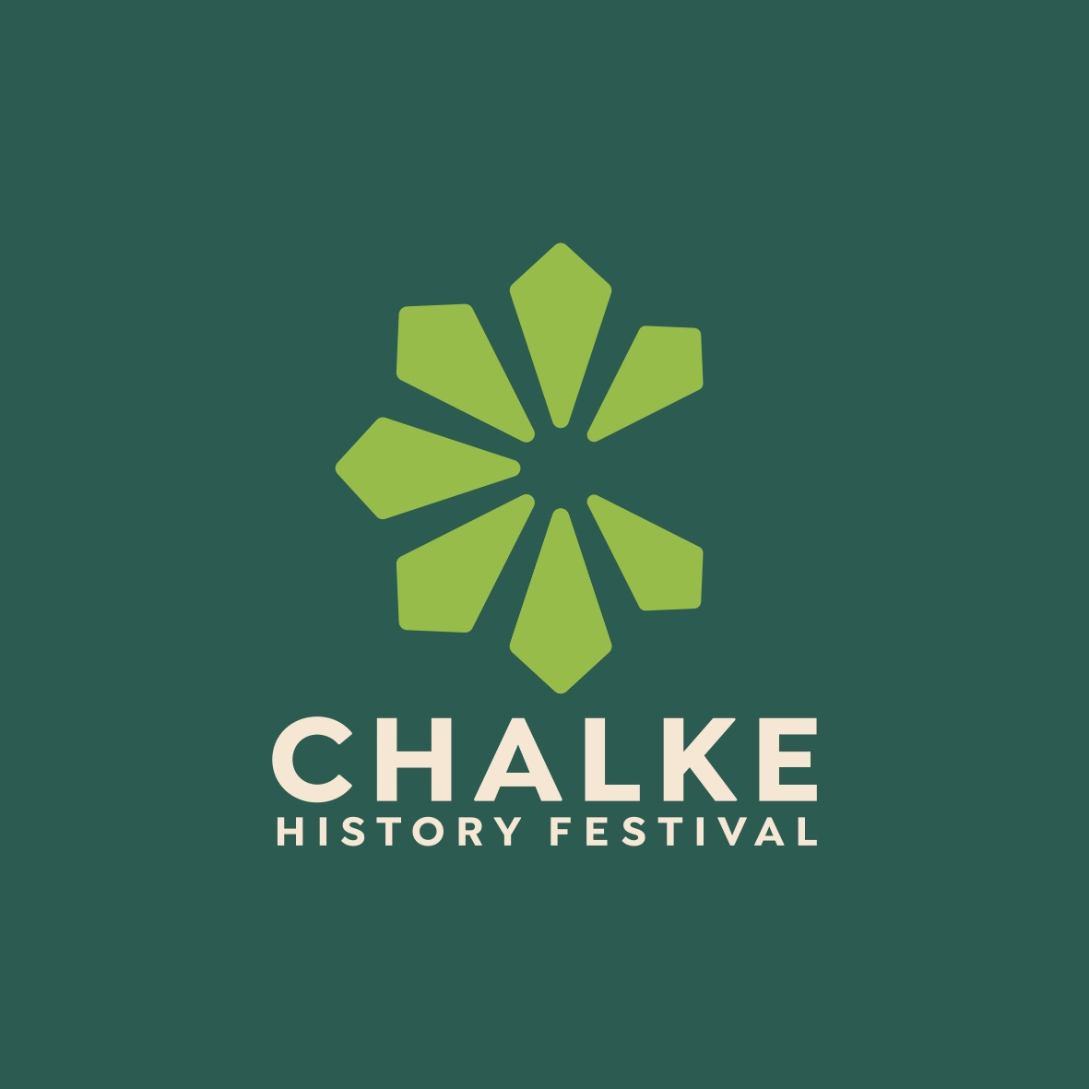

Step back in time at the Chalke History Festival from 24th-30th June

Full programme launched and tickets go on sale

More household names added to the line-up, podcast events in front of a live audience, and the warbirds return after six years

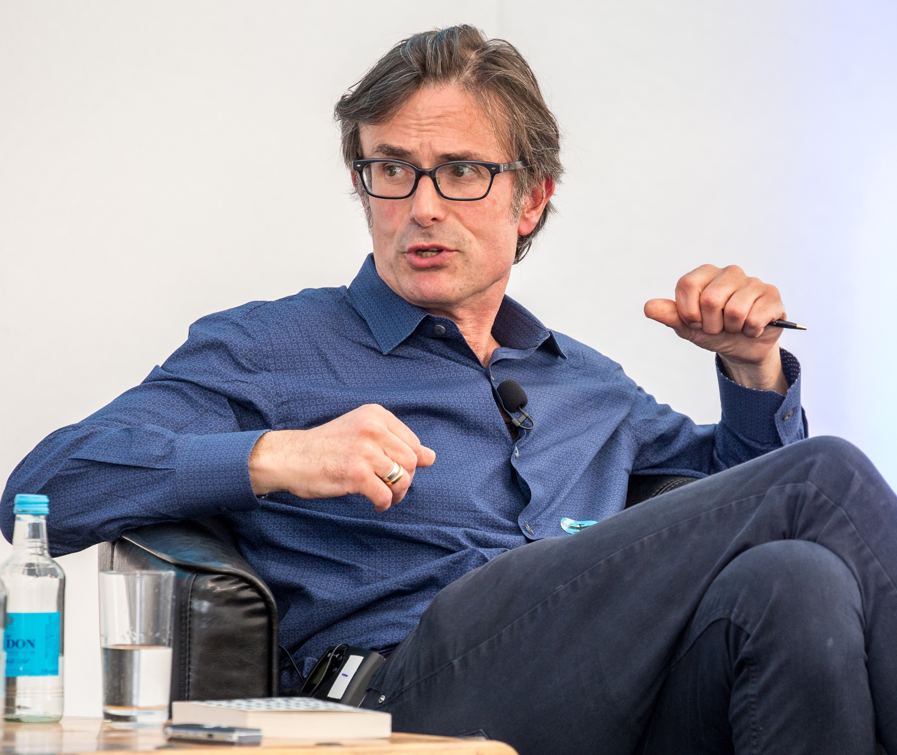
Robert Peston at the Chalke History Festival Photo: Chalke History Festival

Tickets for the UK’s biggest and most successful history festival are now on sale, with the full programme launched and details of all events now live on the newly-relaunched website. With over 130 talks, panel discussions, quizzes, live podcasts and debates, this year’s line-up at the Chalke History Festival is certainly its most varied to date, offering a unique opportunity for visitors of all ages to engage with history in a dynamic and interactive way.

In addition to The Rest of History’s Tom Holland and Dominic Sandbrook, Michael Palin, Zeinab Badawi, Sebastian Faulks, Bettany Hughes, James May and Frank Gardner, further household names have been added to the already-impressive line-up of nearly 200 speakers. Political editor for ITV News and co-host of The Rest is Money podcast Robert Peston returns to the festival this year, this time talking about his latest book Bust in which he says that the country’s economy is flat lining but that things can be made better. Award-winning executive producer and broadcaster for the BBC Kavita Puri makes a welcome return. Fans of BBC TV’s hugely popular sitcom Ghosts will be delighted to learn that co-creators Ben Willbond and Laurence Rickard are set to share behind-the-scenes stories of both writing for and acting in this critically-acclaimed show. International bestselling author and Founder Director of the Women’s Prize Kate Mosse will shine a light on the extraordinary women of the Second World War. And actor and comedian Al Murray, best known for his role as The Pub Landlord, will be taking a night off from his nationwide tour ‘Guv Island’ and performing a very special stand-up routine entitled The First Draught of History in the Spiegel Tent on the Wednesday night. All proceeds will be donated to Finley’s Touch, in memory of Al’s nephew.

To mark the 80th anniversary of D-Day, Second World War enthusiasts are in for treat this June. After an absence of six years, historic warbirds will be just some of the star attractions of the weekend programme. Visitors on the Saturday will be able to see The Spitfire, one of the most iconic aircraft ever built and a symbol of the Allied victory in 1945, flying over the festival site. And on the Sunday, they can watch The Hurricane - which played such a vital role in the Battle of Britain and destroyed more enemy aircraft than all the other air and ground defences combined - return to the skies over the Chalke Valley. In a year that sees the 80th anniversary of D-Day, it will be extra special to witness these stunning and very important aircraft again.

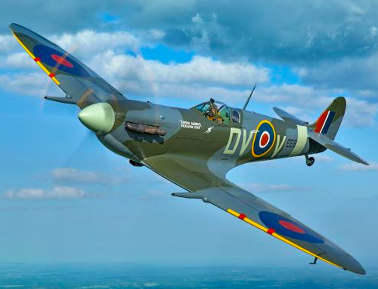
The warbirds return to Chalke

Listening to and meeting Second World veterans is always a huge privilege at the Chalke History Festival and, to commemorate this landmark date, Simon Robinson will be talking to three incredible D-Day ladies - Christian Lamb, Pat Owtram and Betty Webb - about their memories of that historic event. In addition, Kate Vigurs will be in conversation with Joyce Wilding talking about her wartime work as part of the SOE’s ‘camouflage section’ and what it meant to her to have been part of such a remarkable organisation during World War Two. On the Thursday, there will be a special Second World War Day which will feature talks including eminent speakers such as Peter Caddick-Adams, Robert Lyman, Tom Petch and Stephen Prince. Plus, festival favourite and international bestselling author Max Hastings will be presenting his latest book about Operation Biting, which follows the dramatic events of 1942, when the British Intelligence services staged a thrilling commando raid to steal a German radar system.

The Chalke History Festival caters to visitors of all ages, with special activities and entertainment for children and teenagers. From Soldier School and puppetry to arts and crafts, families can create lasting memories together. Back by popular demand is Wizzo’s Rip-Roaring History, an old-time circus sideshow where the stars are the props and extraordinary stories. Think Heath Robinson meets Chitty Chitty Bang Bang and throw in a generous helping of audience participation. Places for the SOE Training Camp are always in hot demand, so visitors should book up early for this unique experience, where both kids and adults can learn the skills and techniques of espionage from the Second World War. The immersive Trench Experience this year will transport those brave enough to participate back to July 1944 and the pivotal battle for Hill 112. Complete with authentic uniforms, equipment, and props, this is a unique opportunity to experience history up close, and to get familiar with the sights, sounds and smells of the Second World War like never before. Children and adults alike will also be thrilled by the news that the colourful Vintage Fairground, with all the thrills of the big wheel and the Helter Skelter, is back - so expect loads of excitement and the occasional scream from that part of the site!

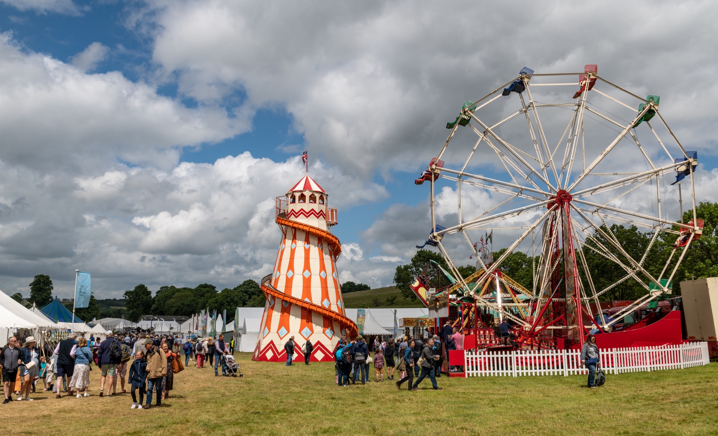
The vintage fairground at the Chalke History Festival Photo by Martin Cook

Listening to podcasts, especially those focussing on history, has never been so popular, with millions of us downloading episodes every day. Throughout the week, audiences will be given a rare opportunity to hear some of these podcasters speak live at the festival. For those who may not have listened to it before, Patrick Bishop and Saul David will be introducing their Battleground podcast - which explores the narratives, turning points and characters that shape conflicts - to the Chalke audience. Two hugely-talented Ukranian academics from Kiev, Hanna Shelest and Victoria Vdovychenko, will be taking part in the Telegraph podcast entitled ‘Ukraine: Rhetoric vs Reality. And, for those wishing to listen to something a little gentler, The National Trust podcast’s James Grasby will be presenting an episode entitled ‘Making History Do The Talking: Bringing People and Places to Life Through Sound’.

For further information, please contact Alex Hippisley-Cox on mobile 07921 127077 or email her at alex@ahipcoxpr.co.uk

The Chalke History Festival will take place at Church Bottom, Broad Chalke, Salisbury, Wiltshire, SP5 5DP. For more details about the festival, please visit the recently relaunched website at www.chalkefestival.com Follow all the news on X at @ChalkeFestival, on Instagram at @chalkehistoryfestival and on Facebook.

About the Chalke History Festival

Attracting the finest and most distinguished historians, academics, leading thinkers, and writers from the UK and abroad, the Chalke History Festival is now firmly established as one of the must-attend events of the festival summer. Taking place on a 70-acre farm, in the heart of the Wessex countryside just outside Salisbury in Wiltshire, it blends inspiring literary talks, discussions and panels with eye-catching and entertaining living history and historical experiences.

