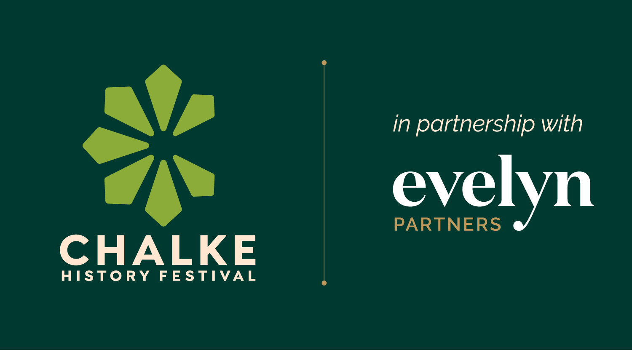

Chalke History Festival – create lasting memories with all the family
from 23rd to 29th June

Chalke Introduces – discover the freshest voices and boldest thinkers as the festival shines a spotlight on the rising stars from the world of history

A range of new thought-provoking and exciting events added to the line-up

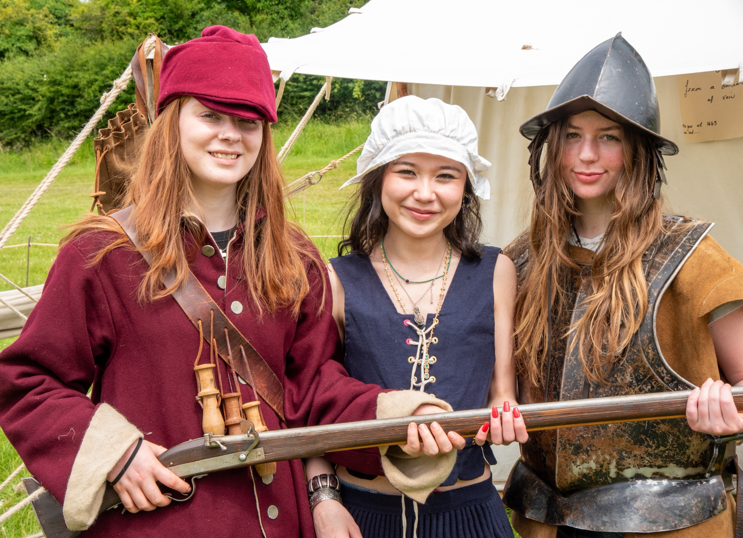
Dressing up in period costumes at Chalke – photo credit: Graham Smith

With less than three weeks to go before the start of this year’s Chalke History Festival, the finishing touches have been made to the stellar line-up of VIP names and expert historians who will be travelling to Broad Chalke this summer. It won’t be long before the familiar sounds of canon fire, sword-fighting and screams of delight from the historic fairground ring out across the Chalke Valley, and hordes of fans arrive for their annual fix of historical facts, live entertainment and the best local food and drink in the county. Supported by lead partner Evelyn Partners, Chalke is simply the place to be and where the summer season really gets started.

Stellar household names, whose attendance is already confirmed for the 2025 festival, include: Antony Beevor, Tracy Borman, William Dalrymple, Tom Holland, Ian Hislop, Helen Castor, Peter Frankopan, Max Hastings, Kate Mosse, James Holland, Michael Palin, Helen Carr, Anthony Scaramucci, Alice Loxton and Kevin McCloud.

World affairs will be at the forefront of debate throughout the week, with the conflicts both in Eastern Europe and the Middle East high on the agenda. Returning to Chalke, the Telegraph team behind Ukraine: The Latest – the world’s most listened-to and award-winning podcast on the war – will be joined by Oleksandra Matviichuk, the Ukrainian human rights lawyer whose Centre for Civil Liberties won the Nobel Peace Prize in 2022, via a live link from Kyiv. At the weekend, a panel of top military experts, brought together especially for Chalke and comprising Mick Ryan, Rob Bertholee, Ben Hodges, John Allen and Richard Shirreff, will be debating the future of NATO and whether it will survive the second Presidency of Donald Trump. Milbank Family Senior Fellow at the Hoover Institution at Stanford University and bestselling author Niall Ferguson will also be taking a look at the current world order, the global crises facing us right now, and giving his expert take on what we might expect in the near future. Plus, James Holland will be joined by weapons expert Hamish de Bretton-Gordon and Mick Ryan to discuss Russia at War: A History of Ineptitude? What lessons has Russia learned from more than a century of bitter, brutal warfare? And, has anything changed in Ukraine?

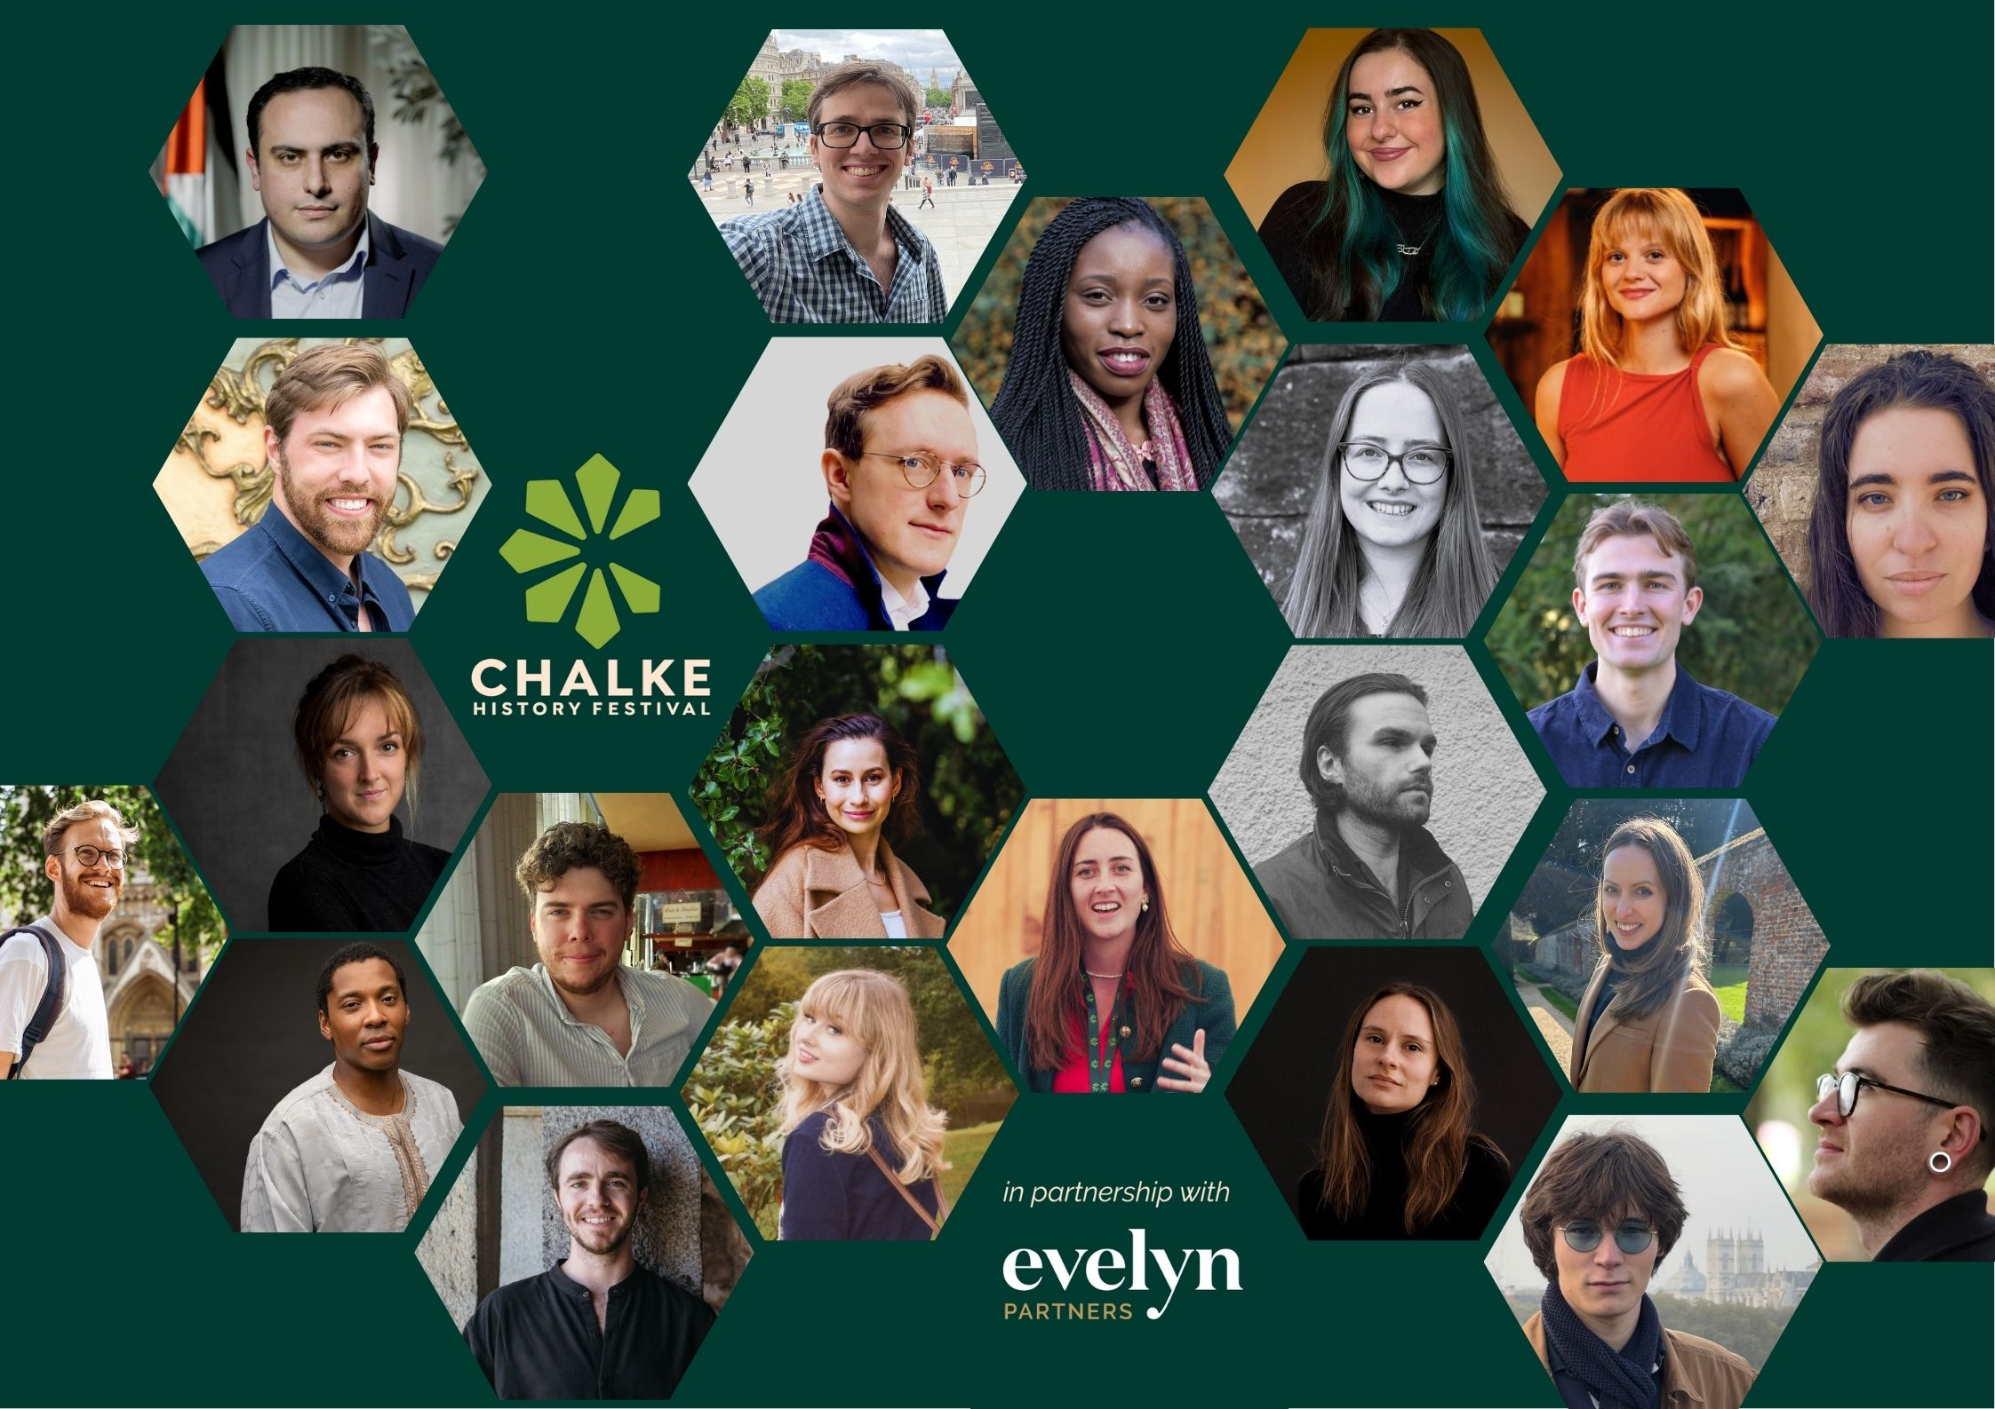
Chalke Introduces – graphic created by the festival team

For the first time this year, the festival will be shining a light on the rising stars from the world of history. A new initiative entitled Chalke Introduces will be giving visitors the opportunity to discover for the first time emerging historians, authors, and storytellers who are reshaping how we explore and understand the past. From buried secrets to digital storytelling, this year’s line-up covers a fascinating range of topics – delving into archaeology, royal intrigue, empire, medieval spirituality, and the rich architectural heritage of Britain. More details about this exciting new series of events and about the speakers themselves can be found here.

As always, Chalke is a time when families get together and create lasting memories whilst exploring the wonders of the past, and this year will be no different. At the weekend there will be a plethora of activities to entertain the kids in the Storystock Children’s Tent of Surprises: Horrible Histories legend Martin Brown will be raising more than a few laughs as he discusses the truly terrible history of the toilet; A F Harrold will be presenting his fun-for-all-the-family poetry show; and the hugely popular author Maz Evans will take the audience on a hilarious journey from the Maya Underworld, through Ancient Egypt and all the way to Camelot to find Excalibur and save the world. Wizzo’s Rip-Roaring History returns with a series of spectacular performances, designed to entertain, whatever age you are. Elsewhere, and new for 2025, visitors can step into the medieval apothecaries’ garden and discover how plants have been used through the centuries, from healing cuts and bruises to dyeing fabrics and creating inks.

British sculptor Laurence Edwards, best known for experimenting with a lost wax casting process to create bronze statues, will also be bringing his unforgettable, monumental Walking Men to Chalke History Festival. Standing 8ft tall, these powerful, post-heroic bronze figures have journeyed all the way from Blenheim Palace to Sydney and will now be a huge talking point in Broad Chalke. Set against the dramatic backdrop of the Chalke countryside, the Walking Men will lead festival goers to the Henge area - to discover thought provoking discussion by day and storytelling, magic and music by night. These extraordinary statues are not to be missed!

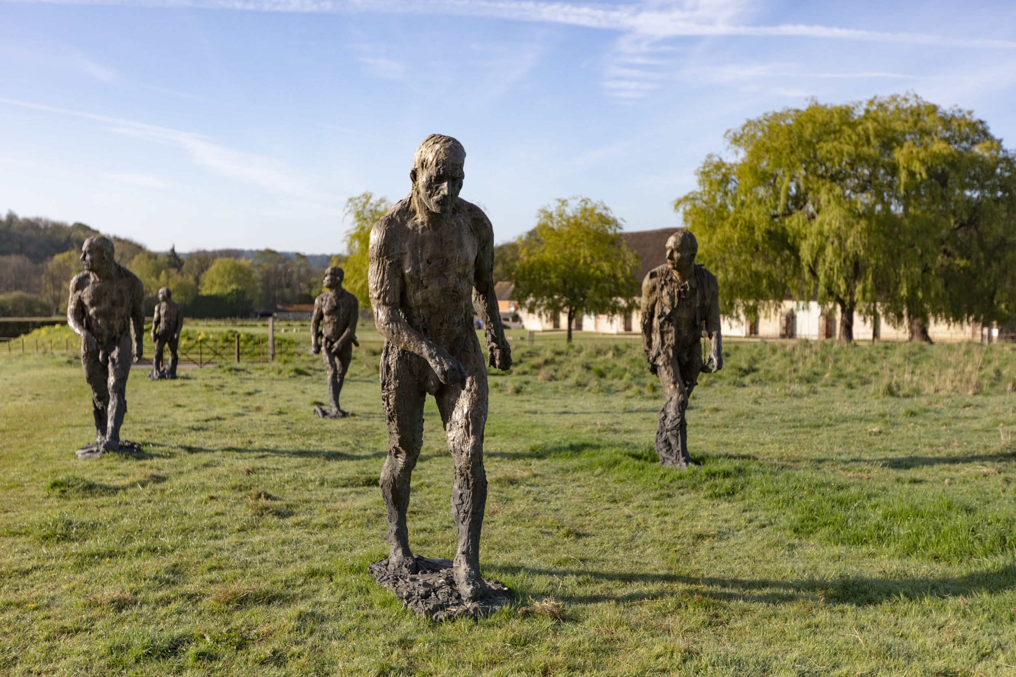
Laurence Edwards’ Walking Men

Back by popular demand, and to kick-start the weekend’s entertainment on the Friday evening, Al Murray’s hilarious The Pub Landlord is back for another round of Guv Island, with some freshly brewed material on the menu and all proceeds going to the charity Finley’s Touch. On Saturday night, Chalke’s very own comedy history quiz Histrionics will be testing the audience’s historical knowledge as Ian Hislop, Al Murray, Anuvab Pal and Katie Kennedy are put on the spot by master of ceremonies Charlie Higson and endeavour to get their heads round the sometimes impossible, and often ridiculous, questions. Live music will round off the night with the UK’s premier wartime group, The D-Day Darlings - returning to Chalke with their selection of stunning original songs and reimagined arrangements of popular wartime tunes – and a DJ set from Uptown Swing, a specialist in danceable swing, jazz and blues tracks from the 30s and 40s. On Sunday morning, once they have hung up their dancing shoes, festival goers will be treated to history maker Lisa Blair’s incredible story of how she became the fastest person to sail solo, non-stop, and unassisted around Antarctica. Through harrowing tales of survival, she will challenge the audience to face change, navigate fear, and drive global action for a sustainable future.

The Chalke History Festival will take place at Church Bottom, Broad Chalke, Salisbury, Wiltshire, SP5 5DP. For more details about the festival, please visit our website at www.chalkefestival.com Follow all the news on X at @ChalkeFestival, on Instagram at @chalkehistoryfestival, on Bluesky at @chalkefestival.bsky.social and on Facebook.
About the Chalke History Festival

Attracting the finest and most distinguished historians, academics, leading thinkers, and writers from the UK and abroad, the Chalke History Festival is now firmly established as one of the must-attend events of the festival summer. Taking place on a 70-acre farm, in the heart of the Wessex countryside just outside Salisbury in Wiltshire, it blends inspiring literary talks, discussions and panels with eye-catching and entertaining living history and historical experiences.
About Evelyn Partners
We are a multi award-winning wealth management group, with a rich heritage going back 188 years. With £62.7 billion of assets under management (as at 30 September 2024) we are one the largest UK wealth managers, with offices across the UK as well as the Republic of Ireland and the Channel Islands.
Our purpose is ‘to place the power of good advice into more hands,’ which we deliver through a range of services. Our expertise includes financial planning and investment management, enabling us to offer clients a truly holistic wealth management service. Through Bestinvest, we also provide an online investment platform and coaching service for investors who prefer to make their own decisions. For further information please visit: www.evelyn.com.

