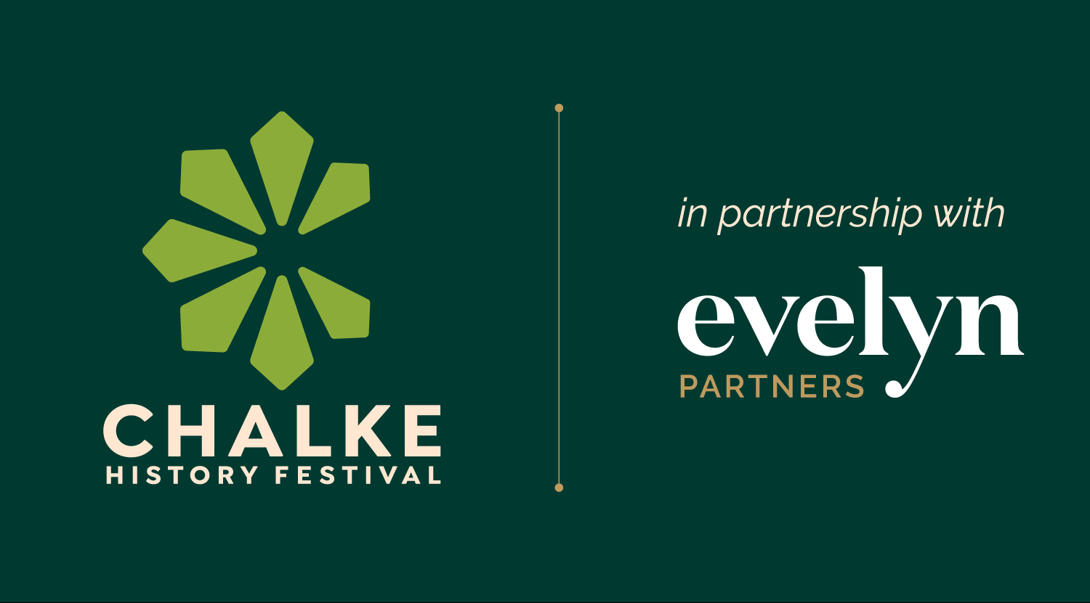

Festival dates: 22nd to 28th June 2026

National treasure Alan Titchmarsh joins list of VIP speakers

Chariots of Chalke: Artisans to reconstruct magnificent late Iron Age Romano-British chariot

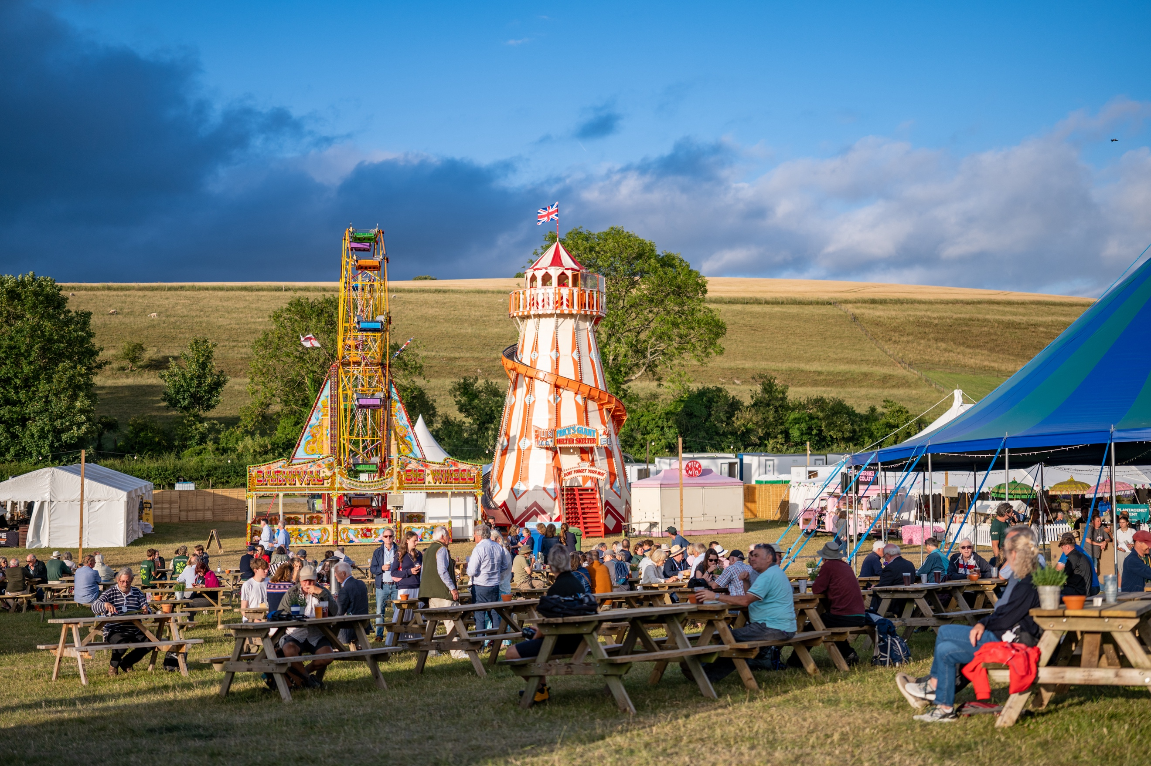
An evening at Chalke History Festival – photo credit: Martin Cook

As the current conflict in the Middle East becomes more concerning with each news report, serious debate and understanding about how the world has got to its most perilous position since 1939 is more important than ever before. How have we got here? Have we not learned any lessons from the past? And what are the consequences? At the Chalke History Festival this June, world leading experts and historians will gather together to try and make sense of it all. Partnered by Evelyn Partners, the UK’s leading history event will be more relevant than ever before and is already attracting a stellar lineup of speakers, thought leaders, influencers and household names.

At Chalke there are always a few attractions that get the crowd talking. In 2025 it was the giant hayrick and the recreation of an eighteenth-century guillotine. This year a team of intrepid artisans will draw on ancient techniques, traditional knowledge, and heritage craft skills to reconstruct a magnificent late Iron Age Romano-British chariot. Working from archaeological evidence and classical sources, they will race against time to create a vehicle worthy of history.
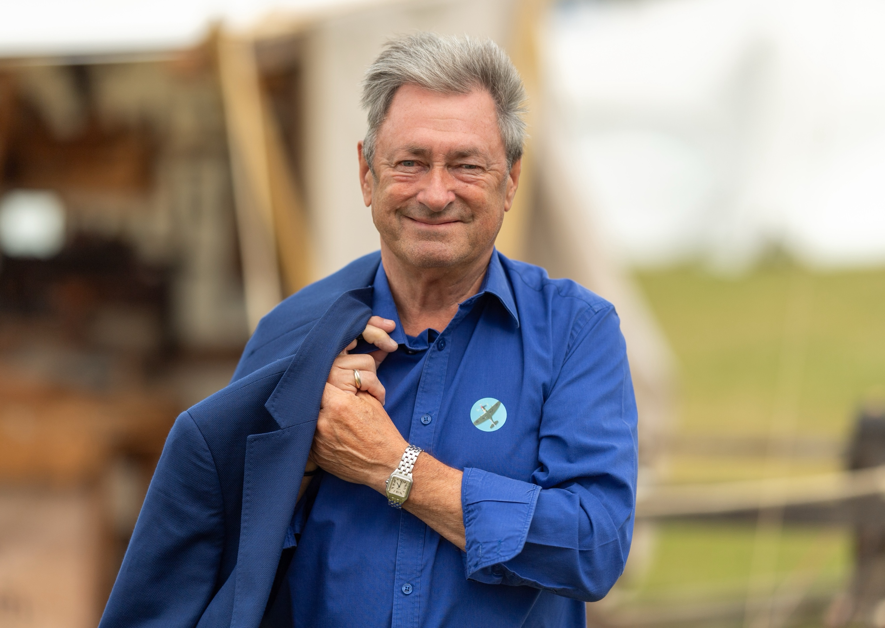
The speaker lineup now includes further big household names, including a number of personalities from the film and TV world. The hugely popular gardener, bestselling author and broadcaster Alan Titchmarsh will give a fascinating talk about gardens for the National Garden Scheme. Award-winning actress, and star of iconic TV series such as Downton Abbey, Wolf Hall: The Mirror and the Light and Killing Eve, Harriet Walter will be making her debut at Chalke when she talks about visibility and representation of older women in the arts. And bestselling author and co-host of The Rest is History podcast Tom Holland will be sharing his passion for cricket when he is joined by former England spin bowler Vic Marks and commentator Simon Hughes as they debate the best England team captains from 1979 to 2025. (Photo of Alan Titchmarsh at Chalke, credit: Martin Cook)

A team from the University of Liverpool returns with more scientific approaches to history, looking beyond the texts and into the past with staff and students from the Department of Archaeology, Classics, and Egyptology. At The First Ceramics session, visitors can find out how exploding figurines and hearty stews have changed everything we knew about the origins of pottery, and why 'Big Picture' models don’t always help us understand what really happened in the past. At the Archaeglueology workshop, fans of the sticky side of the past will be able to get up close with resins, tars, gums and glues from a bygone era, exploring what ancient adhesives were made from, why they mattered, and what they can tell us about the people who made them. And families will get the chance to step into a Roman military encampment and discover what it was like to be a Roman soldier, from military training and drills to Roman artillery.

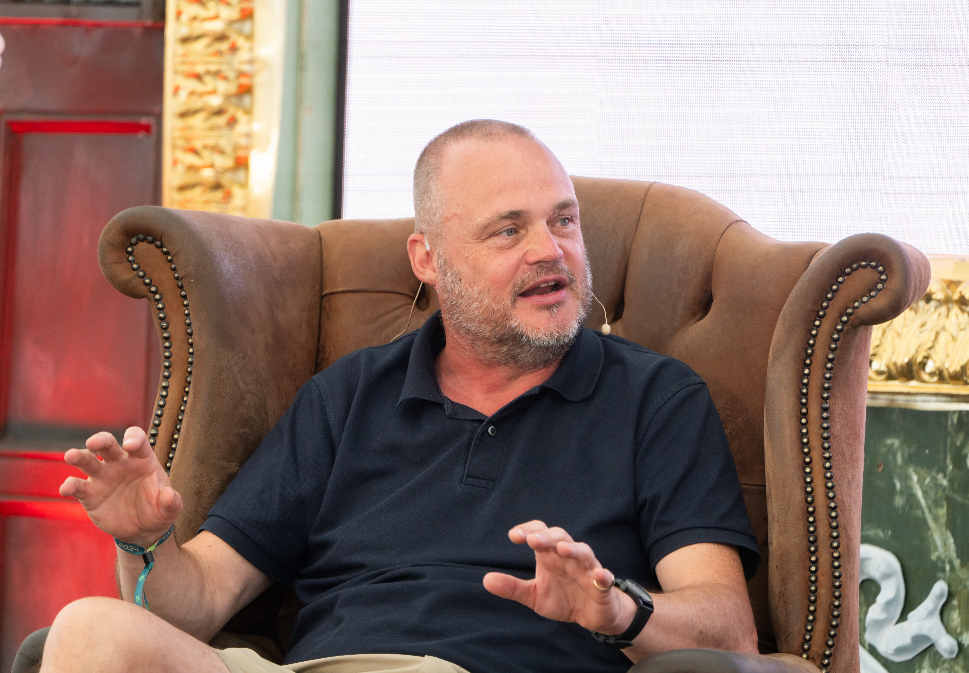
Those history fans with a particular fascination with the Second World War, and the lead up to it, are in for a treat this June. Bestselling author and an expert on the world’s most infamous special forces unit Damien Lewis will be sharing tales of high-stakes operations and undercover rescues undertaken by the SAS; co-hosts of the hugely popular podcast We Have Ways of Making You Talk Al Murray and James Holland will be discussing the sinking the Bismarck in May 1941; leading scholar of international humanitarian law, human rights, and criminal law Theodor Meron will be coming to Chalke for the first time to talk about surviving the Holocaust, serving as a judge and his role as the President of the International Criminal Tribunal for the former Yugoslavia; the ever-popular WW2 veteran Colin Bell returns, aged 105, to recollect the time when he flew fifty missions over Germany as a Mosquito pilot; Saul David on Tunisgrad will present his gripping new account of the campaign in Africa; and Katja Hoyer will talk about her much-anticipated book about life during the rise and reign of Hitler through the eyes of the people of Weimar. (Photo of Al Murray at Chalke, credit: Ash Mills)

This year’s festival will have a distinctive nautical theme. As audiences enter the site, they will set eyes on a stunning replica 40ft Coastal Motor Boat, originally built in 1916 and designed to pass through a minefield to deliver a single18-inch Whitehead torpedo. This will be accompanied by dynamic demonstrations from expert shipbuilders based at Portsmouth Historic Quarter.

Elsewhere, the all-inclusive ticket system will allow visitors to attend a wide variety of talks, all for the price of an entrance ticket. Michael Livingston and Dan Jones will be discussing the Two Hundred Years War, the longest military conflict in European history;
Emily Hauser will tell the astonishing true story of the real women behind ancient Greece’s greatest legends; Paul Beaver and Nigel West will swap stories about the secret world of undercover assassins; Amy Jeffs is back to talk about traditional ballads; Thomas Asbridge assesses the global impact of The Black Death; Hallie Rubenhold introduces her page-turning, feminist retelling of the historical true-crime story of infamous wife-murderer Dr Crippen; and Jonathan Freedland will share tales of bravery in the face of tyranny as he discusses his bestselling book The Traitor’s Circle.

Following the success of the Henry V performances last year, the On Cue Theatre Company brings Shakespeare back to Chalke with their lively and dynamic performances of ‘The Tragedie of Macbeth’. Audiences will be transported back to the Elizabethan period and discover how the Elizabethan players originally performed with minimal rehearsal, no director, and working from cue scripts.

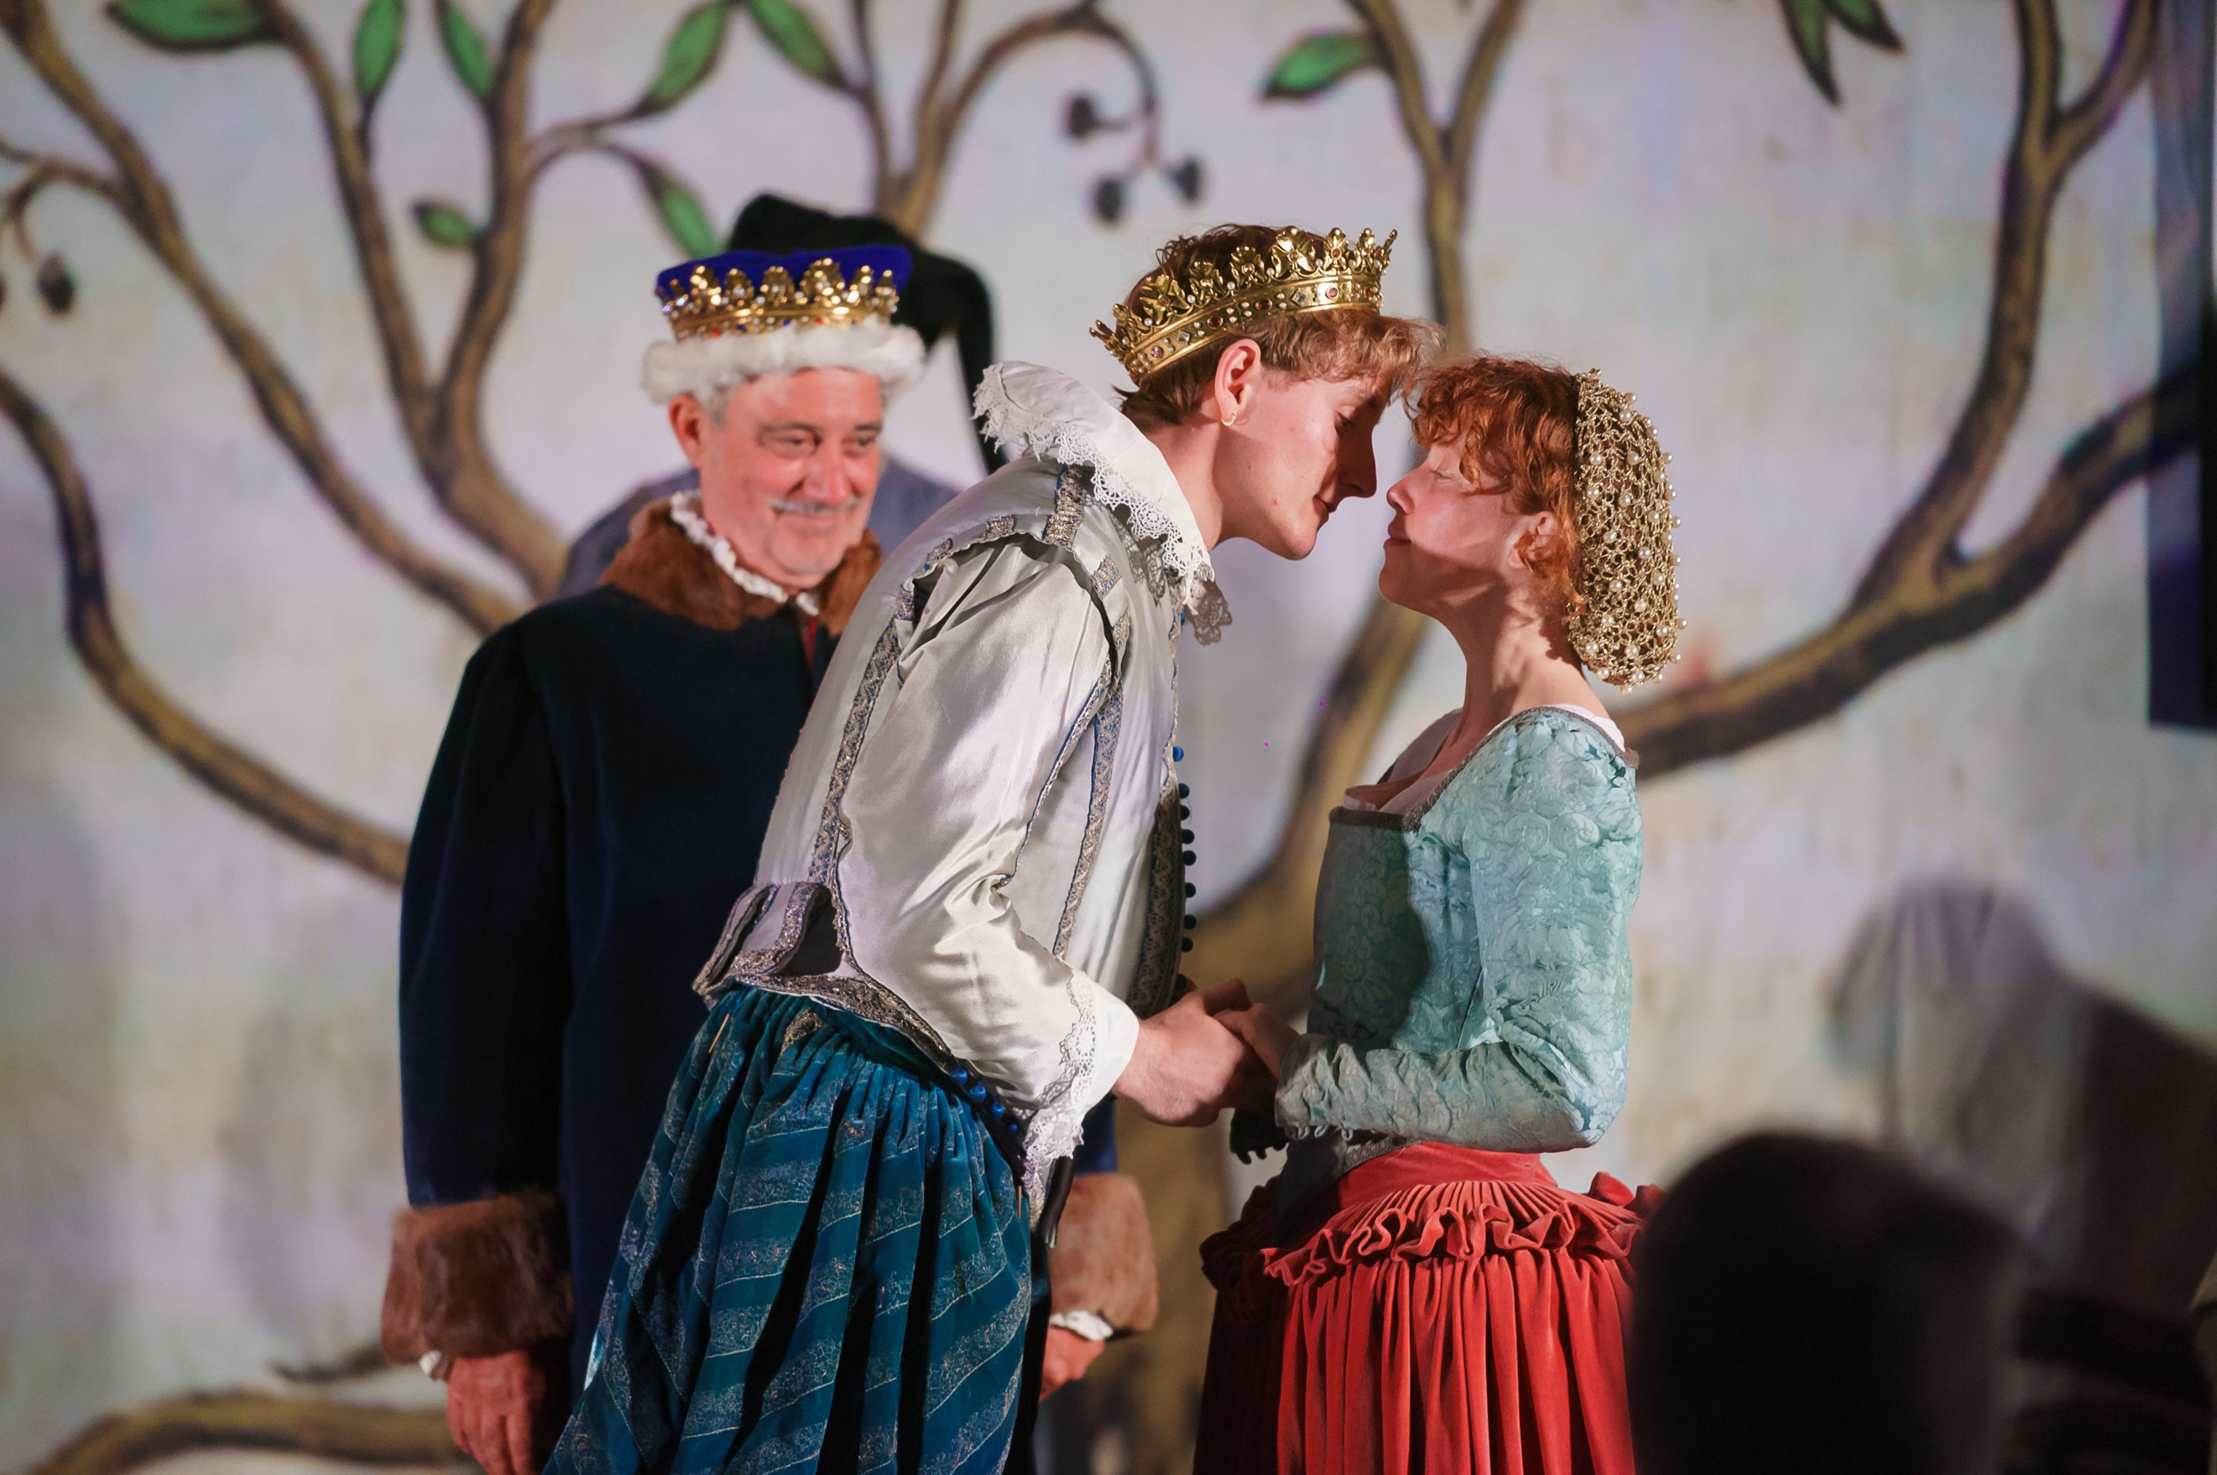
Henry V at Chalke in 2025 – photo credit Ash Mills

Another eye-catching production will take place on Monday 22nd June when the Liberata Collective will put on a performance of Antonia: Behind the Myth of Marie Antoinette. Conceived as an Opera Portrait, it places a singular female figure at its centre, weaving music, text, and Baroque Gesture into a theatrical exploration of identity, influence, and power. Written as an intimate retelling of the lesser-known parts of Marie Antoinette's life story, it explores the queen's experiences through the music that surrounded her.

The hugely popular and informative Chalke History Festival for Schools runs from Monday 22nd June to Wednesday 24th June, with the Wednesday being solely a SEND day for all school ages. On this day, the site will be much quieter than the normal mainstream school days, with no loud or sudden noises. Further information and details on how to book can be found on the festival website here with the already impressive programme being announced in full very soon.

Under the mid-summer sun, and with the fantastic lineup on speakers and performers, the Chalke History Festival promises to be the must-attend event for all history buffs. With the smell of mouth-watering locally produced food, the clink of ice in glasses at the centrally located bar, the lure of quality shopping at the Emporium, and an impressive list of musical acts already confirmed, there will be something for all the family at this annual historical extravaganza.

3- and 7-day tickets are on sale now. The full programme and day tickets for the Chalke History Festival will be available from 22 April 2026.

The Chalke History Festival will take place at Church Bottom, Broad Chalke, Salisbury, Wiltshire, SP5 5DP. For more details about the festival, please visit our website at www.chalkefestival.com Follow all the news on X at @ChalkeFestival, on Instagram at @chalkehistoryfestival, on Facebook and on LinkedIn.

About the Chalke History Festival

Attracting the finest and most distinguished historians, academics, leading thinkers, and writers from the UK and abroad, the Chalke History Festival is now firmly established as one of the must-attend events of the festival summer. Taking place on a 70-acre farm, in the heart of the Wessex countryside just outside Salisbury in Wiltshire, it blends inspiring literary talks, discussions and panels with eye-catching and entertaining living history and historical experiences.

About Evelyn Partners
Evelyn Partners is a leading wealth management group, created through the merger of Tilney and Smith & Williamson in 2020, with a rich heritage of supporting individuals, families, and charities with the financial affairs for 189 years. With £67.0 billion of assets under management (as at 30 September 2025), we are one of the largest UK wealth managers ranked by client assets.

Through an extensive network of offices in 21 towns and cities in the UK, as well as the Republic of Ireland and the Channel Islands, we support private clients, family trusts, and charities, as well as provide investment solutions to financial intermediaries. Our diverse client base includes entrepreneurs, C-suite executives, partners of professional firms and sports professionals.

Our expertise spans both award-winning financial planning and investment management, enabling us to offer clients a truly holistic total wealth management service. Through Bestinvest, we also provide an online investment platform and coaching service for self-directed investors, consistent with our purpose of ‘placing the power of good advice into more hands’.

