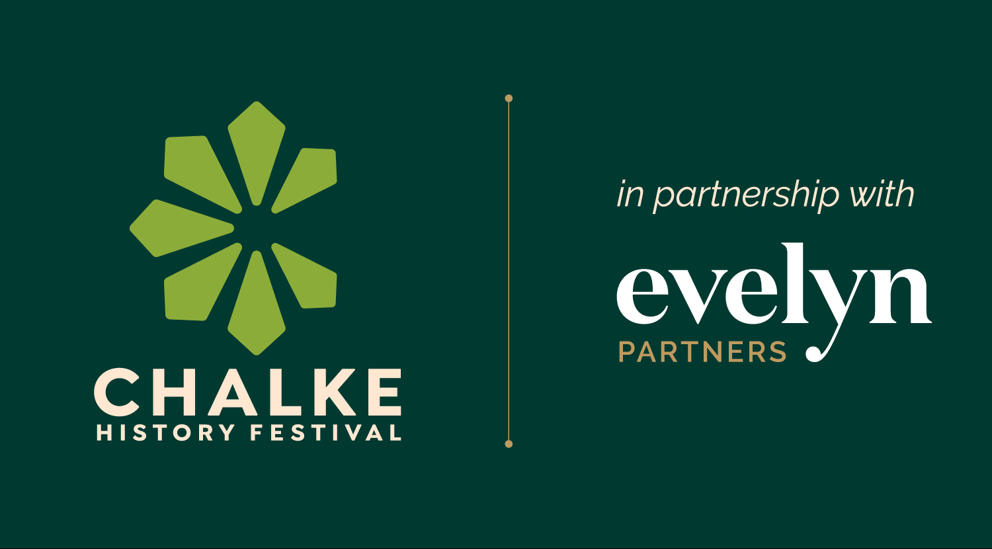

Save The Date: 22nd-28th June 2026

CHALKE: history is our compass, guiding us as we navigate
our complex world

Headline speakers already confirmed as dazzling 2026 lineup takes shape

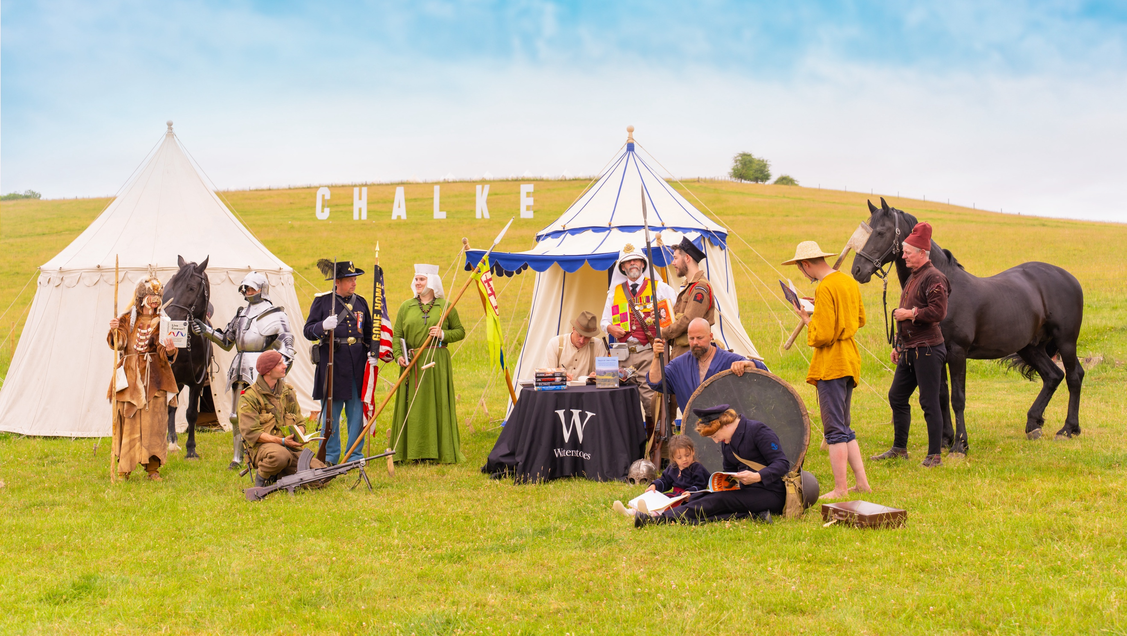
Living Historians attend a book signing on the hill at Chalke – photo credit Ash Mills

Set in the heart of the stunning Wiltshire countryside, the Chalke History Festival - the UK’s leading celebration of history – will return from 22nd to 28th June 2026 to bring the past vividly to life through a rich programme of top-class talks, wide-ranging discussions, striking performances and dynamic living history experiences.

A hugely popular annual event, attracting large numbers of visitors from home and abroad, Chalke is a celebration of curiosity, critical thinking and the power of storytelling, bringing together many of the world’s most respected historians, authors and thinkers to explore the people, events and ideas that have shaped our world. From ancient civilisations to modern global history, the festival offers audiences of all ages the chance to engage directly with history’s biggest stories, the debates they continue to inspire today, and an opportunity to meet expert historians face-to-face in an informal, festival atmosphere. All the time experiencing the very best local food, drink, live music and the chance to camp under the stars or chat with fellow history buffs around an open fire.

In partnership with Evelyn Partners, this year’s dazzling lineup already promises to have something for everyone - from lifelong history enthusiasts to curious newcomers – and boasts an impressive list of VIP names, some of whom will be appearing at the festival for the very first time. The popular streamlined ticketing system, introduced last year, now ensures that festival entry grants access to all talks at no additional cost. Under-16s can attend for free, and early bird pricing is available until 21st April, making this festival more accessible than ever before.

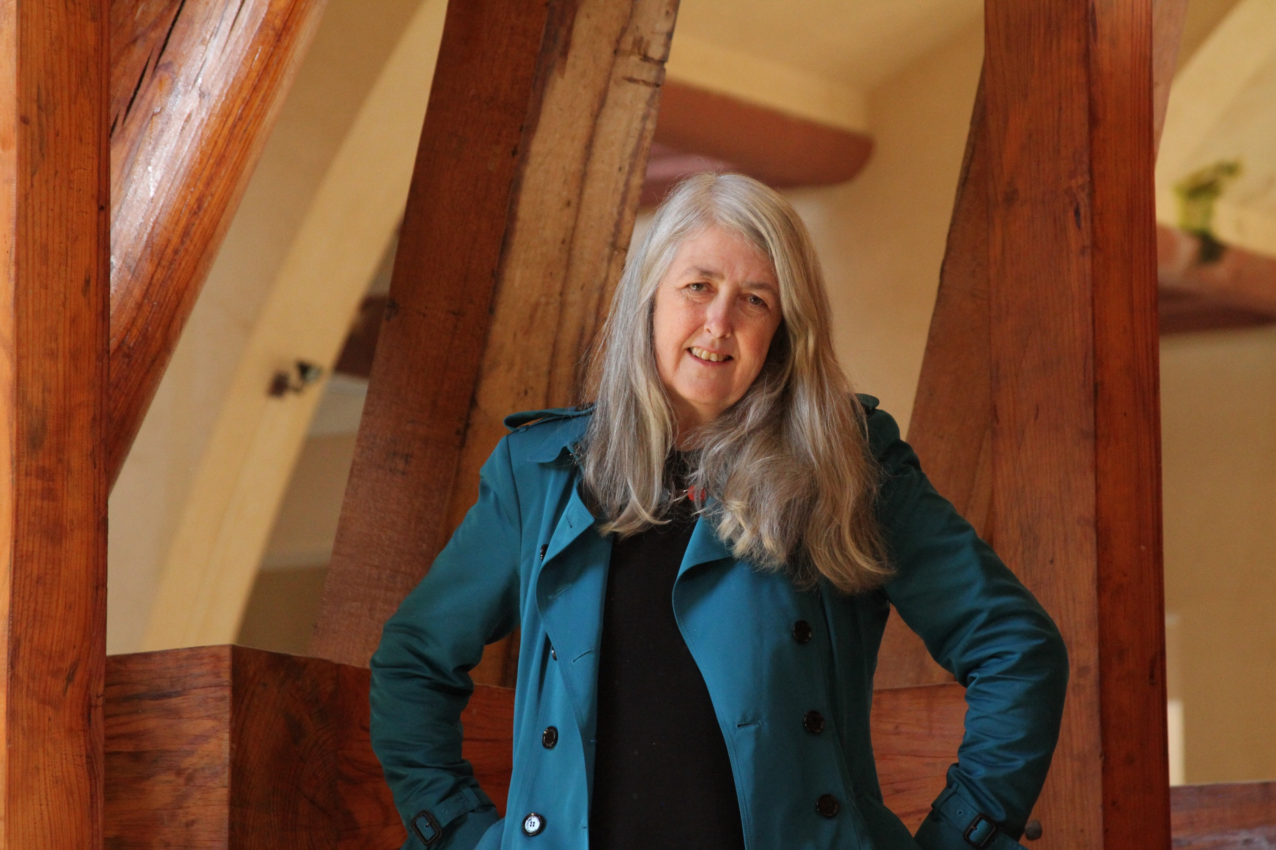
This summer bestselling author and Britain’s most celebrated classicist Mary Beard will make her debut when she chats with her son Raphael Cormack about family histories and why the deep past really does affect us all. Chalke will also be marking the 250th anniversary of the US Declaration of Independence with a series of events including renowned American journalist and commentator Anne Applebaum with radio presenter and journalist James Naughtie, and Simon Jenkins presenting his latest book A Short History of America: From Tea Party to Trump. Former White House Communications Director and financier Anthony Scaramucci makes a welcome return to discuss the road to war in the 1920s and 30s with James Holland. Elsewhere there will be a distinctly naval theme this time, with Thursday’s Second World War Morning being devoted to discussing U-boats, convoys and the battle for the maritime supremacy, and distinguished historian N.A.M. Rodger talking about The Price of Victory: A Naval History of Britain. (Photo: Mary Beard, credit: Caterina Curroni and Lion TV)

Bookings are already open for the Chalke History Festival for Schools which will run on the first three days: primary schools on Monday 22nd June, secondary schools on Tuesday 23rd June and Wednesday 24th June being ear-marked for SEND pupils who might prefer a quieter atmosphere. Students will get the rare chance to listen to renowned historians talk about curriculum-based subjects and allowing them to see, hear and feel the past in unforgettable ways. Speakers and performance artists already confirmed include Ben Kane talking about Roman Britain, Kate Mosse discussing Feminist History, Thomas Asbridge speaking about the global impact of The Black Death, Kate Vigurs telling the story of legendary war correspondent Lee Miller, and Clare Jackson on the change from the Tudor to the Stuart dynasties. Further topics to be covered at the schools festival will the History of Medicine, Cold War, Second World War, Migration, America 250 and Medieval Women.

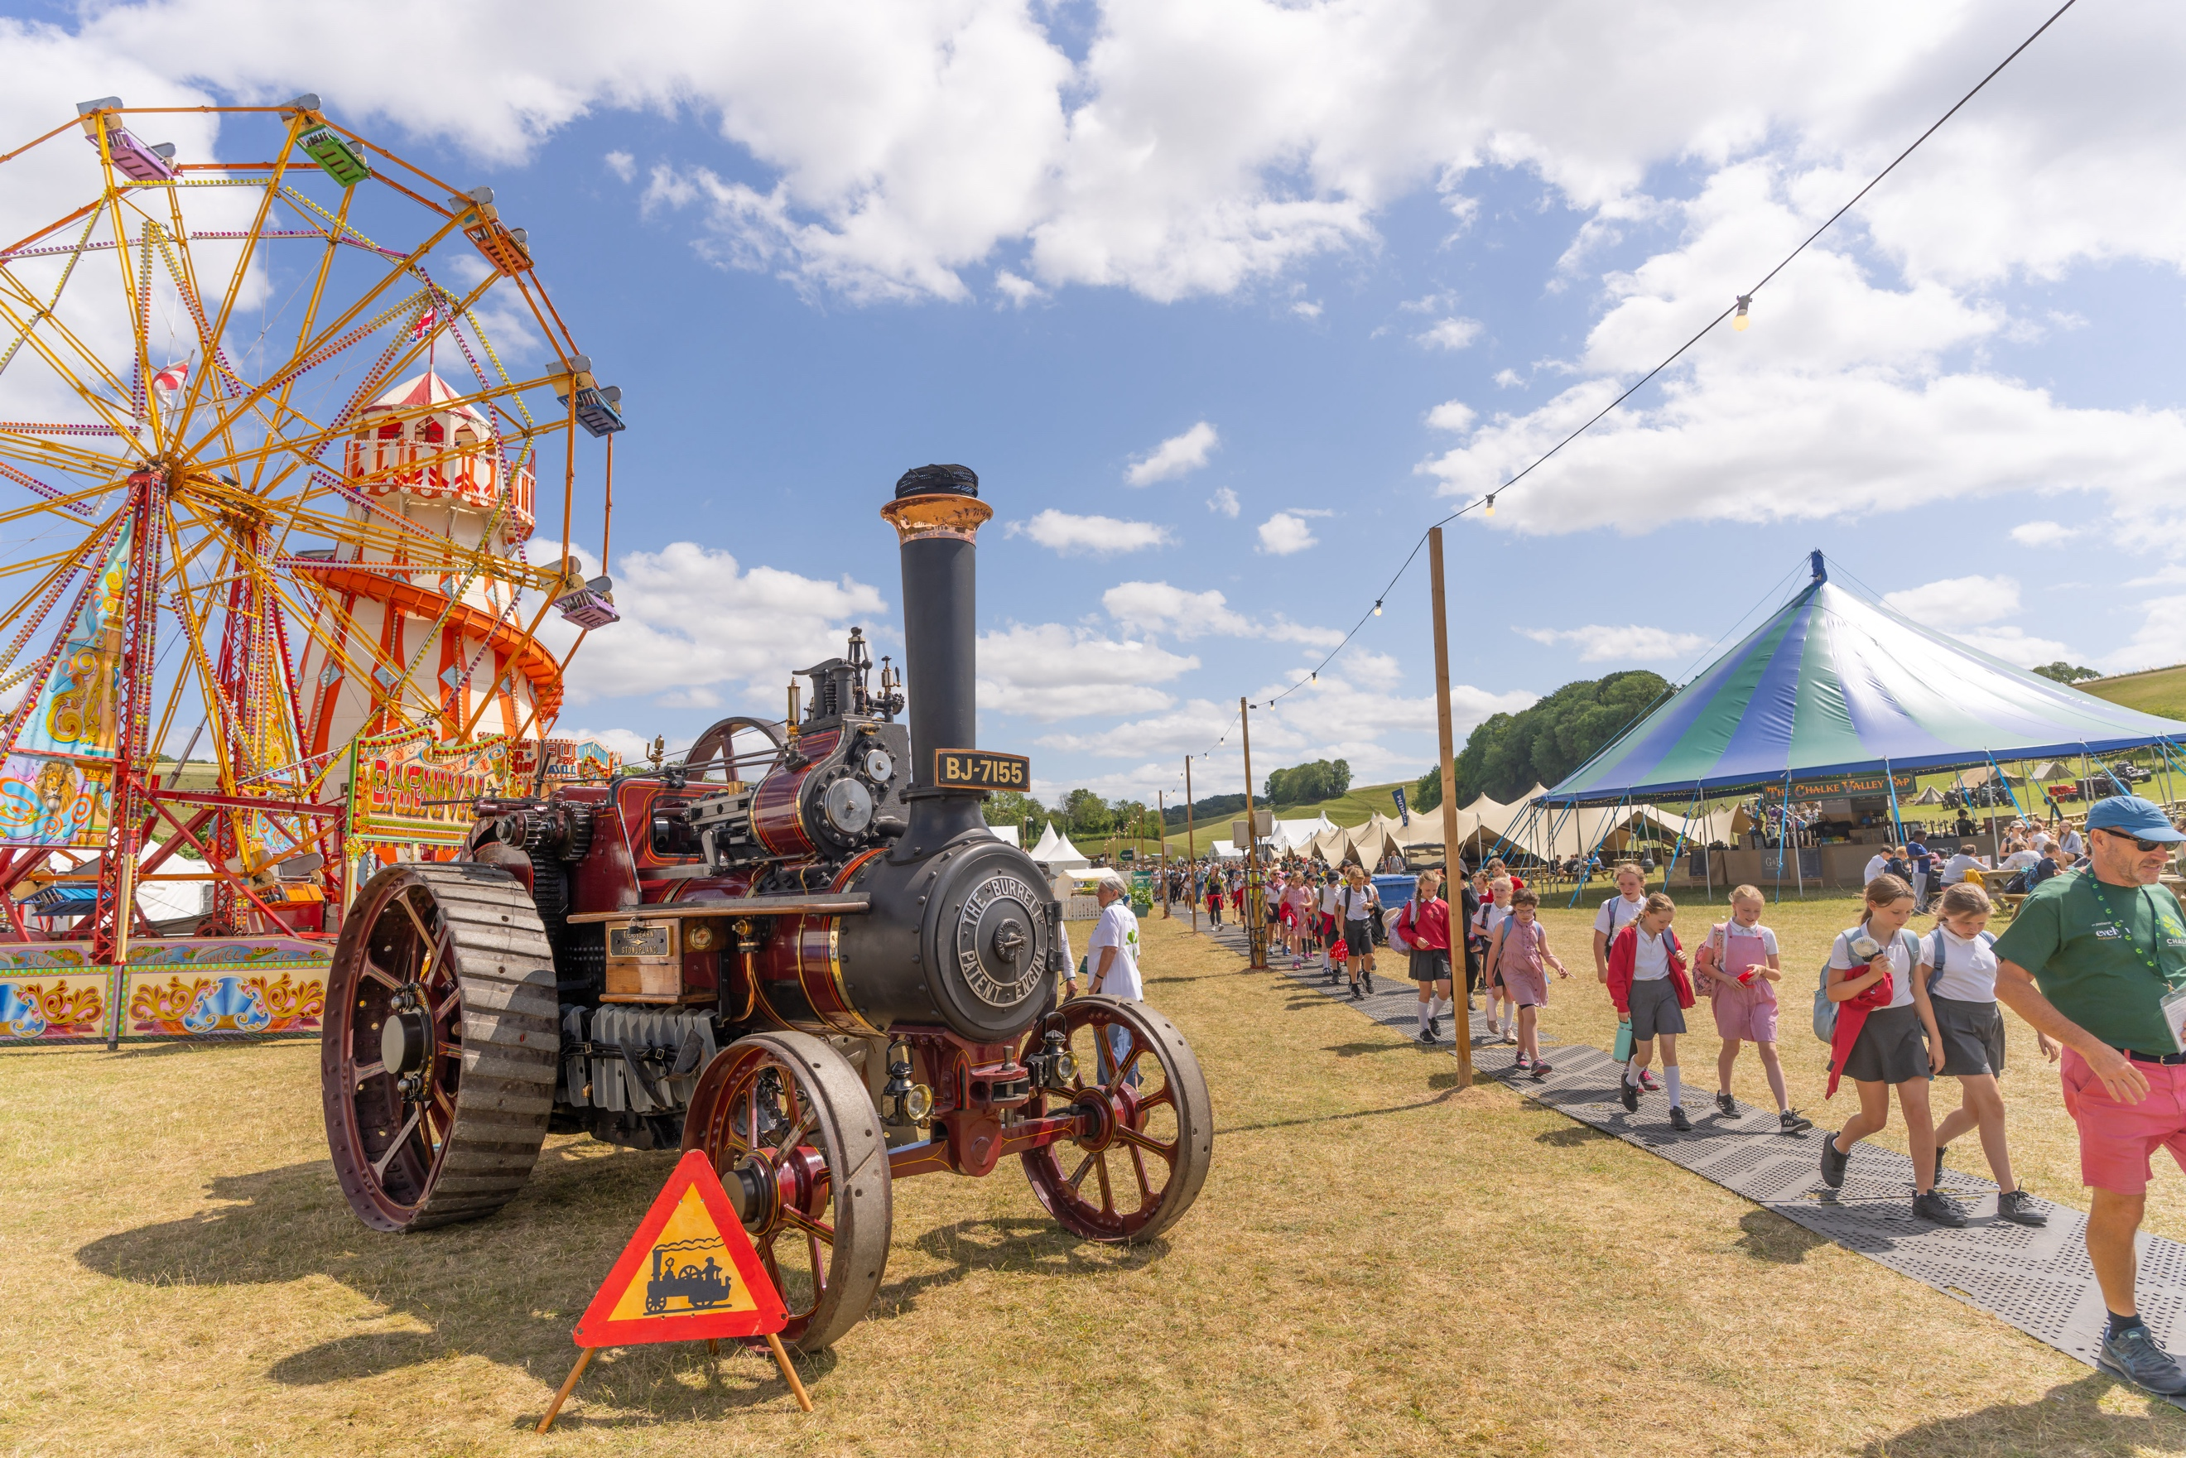
School children on site at the Chalke History Festival – photo credit Ash Mills
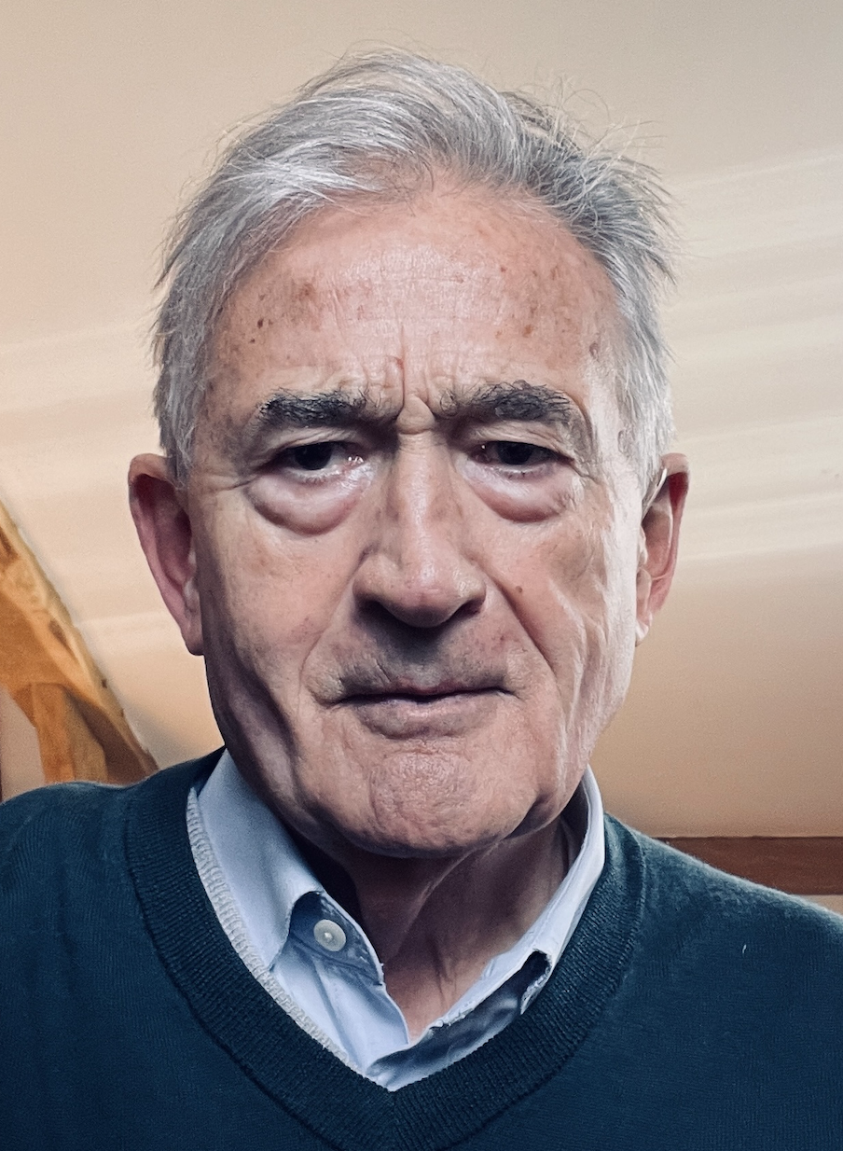
The stellar lineup for 2026 already includes: Antony Beevor on Rasputin, the wild mystic who laid the ground for the Russian Revolution; Kate Williams on her highly anticipated book Regina: A New History of Women and Power; Alan Allport on how the Second World War reshaped the world; Alice Loxton on following in the footsteps of Eleanor of Castile; Lawrence Freedman on strategists and strategy; Andrea Wulf on the life and times of the explorer and revolutionary George Foster; historical fiction sensation Elodie Harper on Boudicca’s Daughter; Shadow Leader of the House of Commons Jesse Norman and former chief economist at the Bank of England Andy Haldane on the 250th anniversary of the Wealth of Nations; Gordon Corera and John Tregoning on biological warfare; Justine Picardie on Fashioning the Crown; and Tracy Borman on her new historical novel The House of Boleyn. (Photo: Antony Beevor)

Audiences are also now able to book onto one of Chalke’s unique workshops to get a rare and special insight into the world of historic crafts and activities. On the first three days of the festival, Thimblerig Games will be running interactive sessions for schools exploring historic games. Hiow Beorht will also be hosting medieval calligraphy, tablet weaving, and bookbinding workshops on Thursday. And resident stonemason Andrew Ziminski will be offering stone-carving workshops on Tuesday night and Friday. There will also be a range of different workshops available on Saturday. Tickets are available to book now at https://www.chalkefestival.com/experiences/

Music by the bar is always a hugely popular part of the Chalke offering, creating a real festival atmosphere in the evenings and over the weekend. At the start of the week, the lineup will focus on music with traditional roots, such as folk and Americana. After a roaring success last year, the barn dance will return on Thursday night, followed by headliners The Trouble Notes, a violin-led cinematic progressive folk rock trio. On Friday night, audiences can discover their inner Super Trouper with tribute act Abba’s Angels. On Saturday, the D-Day Darlings will delight with their vintage melodies, followed by The Brass Funkeys, a 9-piece collective bringing creativity, groove, and infectious energy to the Forum stage.

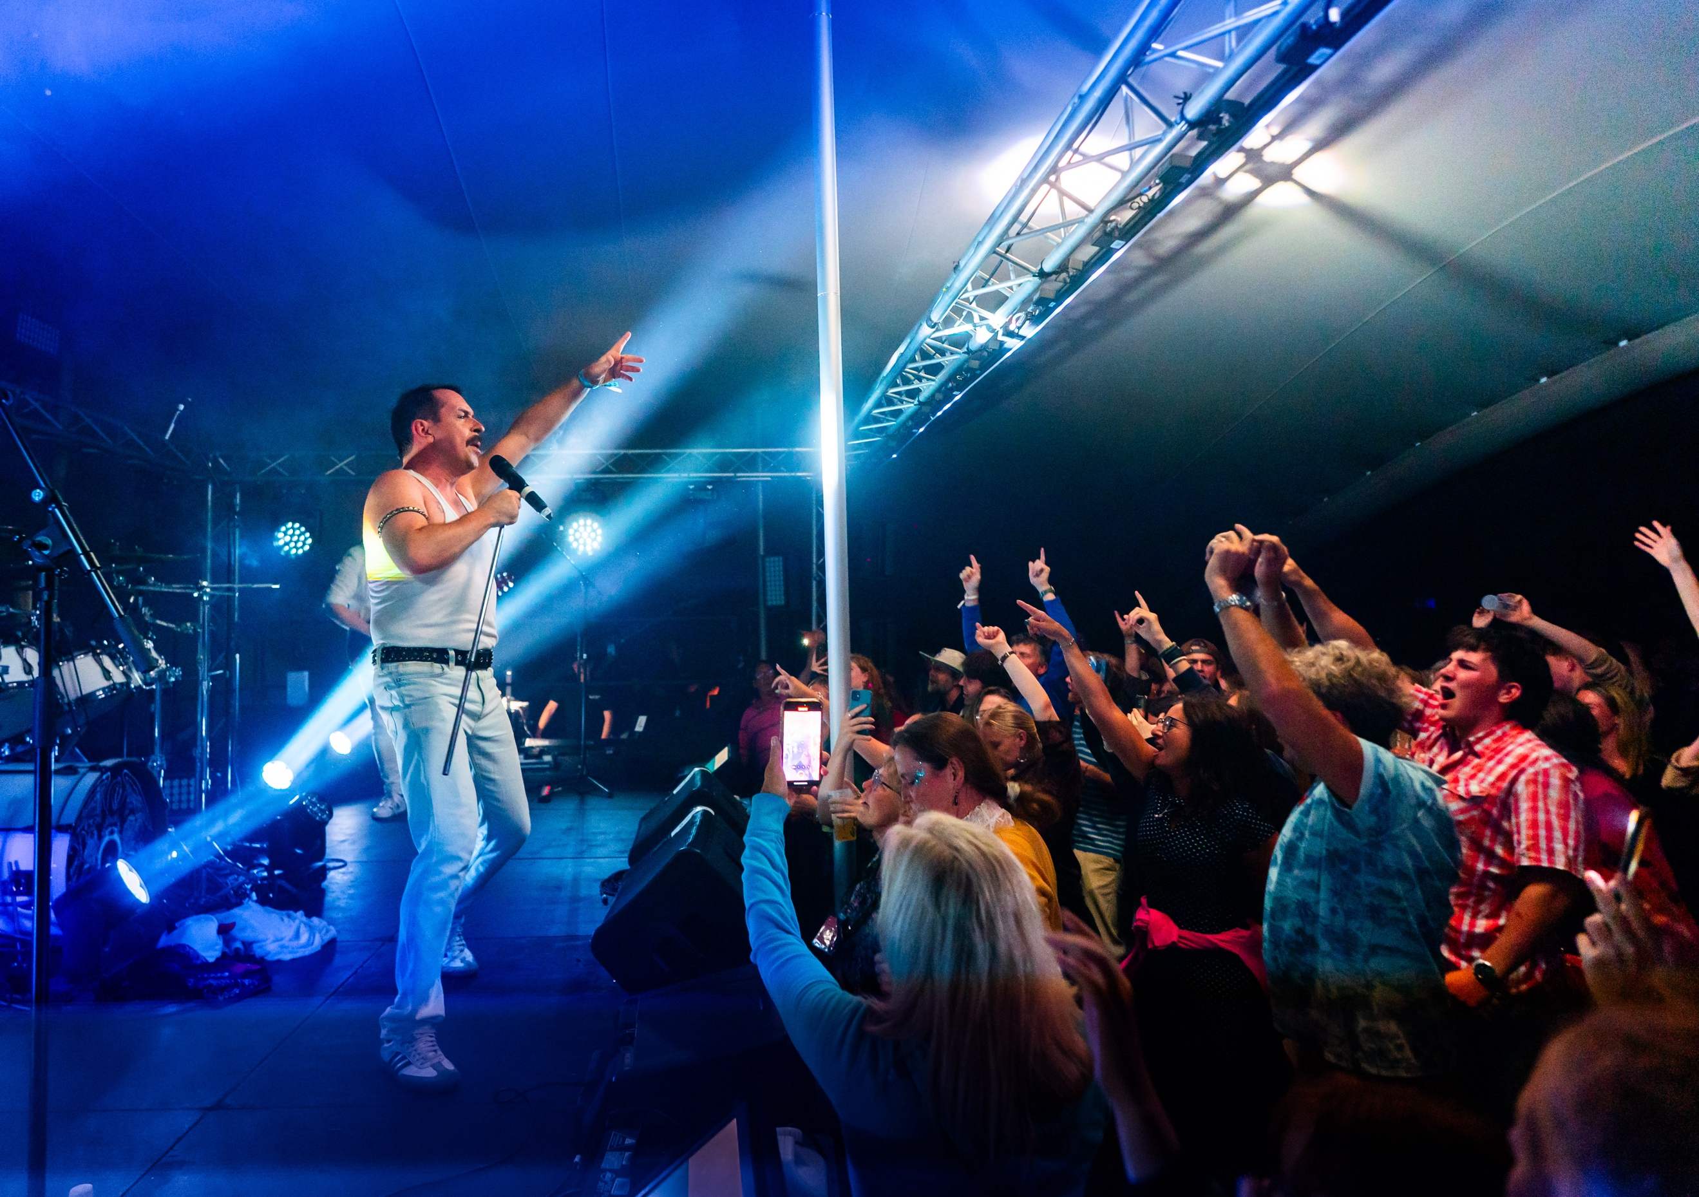
Live music on Friday night at Chalke – photo credit Ash Mills
The Chalke Introduces programme, which gives a platform at the festival to up and coming young historians, will also return after its successful launch in 2025. Rising stars Hetta Howes, Verity Babbs, Jess Venner, and Adam Hart have already confirmed their participation.

3 and 7 day tickets are on sale now. The full programme and day tickets for the Chalke History Festival will be available from 22 April 2026.

The Chalke History Festival will take place at Church Bottom, Broad Chalke, Salisbury, Wiltshire, SP5 5DP. For more details about the festival, please visit our website at www.chalkefestival.com Follow all the news on X at @ChalkeFestival, on Instagram at @chalkehistoryfestival, on Facebook and on LinkedIn.

About the Chalke History Festival

Attracting the finest and most distinguished historians, academics, leading thinkers, and writers from the UK and abroad, the Chalke History Festival is now firmly established as one of the must-attend events of the festival summer. Taking place on a 70-acre farm, in the heart of the Wessex countryside just outside Salisbury in Wiltshire, it blends inspiring literary talks, discussions and panels with eye-catching and entertaining living history and historical experiences.

About Evelyn Partners
Evelyn Partners is a leading wealth management group, created through the merger of Tilney and Smith & Williamson in 2020, with a rich heritage of supporting individuals, families, and charities with the financial affairs for 189 years. With £67.0 billion of assets under management (as at 30 September 2025), we are one of the largest UK wealth managers ranked by client assets.

Through an extensive network of offices in 21 towns and cities in the UK, as well as the Republic of Ireland and the Channel Islands, we support private clients, family trusts, and charities, as well as provide investment solutions to financial intermediaries. Our diverse client base includes entrepreneurs, C-suite executives, partners of professional firms and sports professionals.

Our expertise spans both award-winning financial planning and investment management, enabling us to offer clients a truly holistic total wealth management service. Through Bestinvest, we also provide an online investment platform and coaching service for self-directed investors, consistent with our purpose of ‘placing the power of good advice into more hands’.

