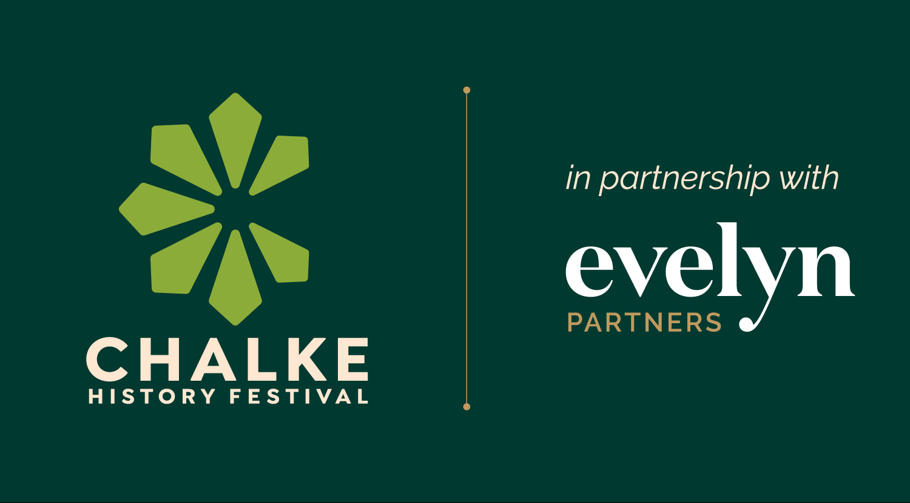

Chalke History Festival: 22nd to 28th June 2026

Tickets now on sale – VIP lineup includes Mary Beard, Alexander Armstrong, Anthony Scaramucci, Harriet Walter and Alan Titchmarsh

David Hare to headline the inaugural Tom Stoppard Conversation

More immersive history, performances, live music and workshops than ever before

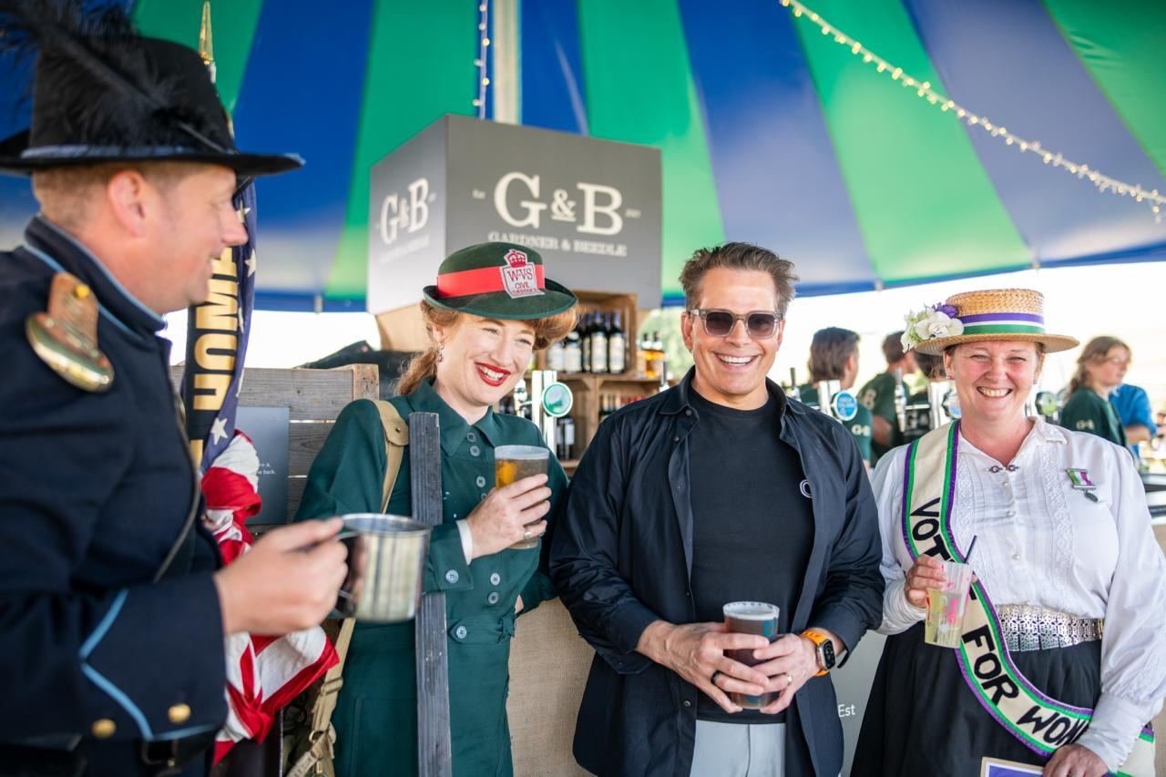
Anthony Scaramucci with living historians at Chalke in 2025 Photo: Martin Cook

The programme has been announced, and tickets are now on sale for this year’s Chalke History Festival. Taking place from 22nd to 28th June, and sponsored by Evelyn Partners, this year’s event promises to be one of the stand-out occasions of the summer calendar, attracting the very top names and boasting a lineup of leading historians, household names and expert commentators whose views and analysis of both historical events and current world affairs are second to none. Alongside a tantalising line up of talks, discussions and debates, the programme for fans of getting up close and personal with history through immersive experiences, theatrical performances, hands-on activities and live music is more varied and eye-catching than ever before.


Attendees at the festival this June will be able to spot the following VIP names mingling with the crowds, with some attending Chalke for the first time: Mary Beard and her son Raphael Cormack will be discussing how historians make sense of lives that can seem strange or distant to modern eyes; James Naughtie, Sarah Churchwell, Nicholas Guyatt and Anne Applebaum will take part in two events on the Tuesday evening to mark the 250th anniversary of the US Declaration of Independence. On Monday evening Anthony Scaramucci, whose visit in 2025 drew record crowds and a flurry of media attention, will be talking to James Holland about the road to war in the 1920s and 30s. Other highlights throughout the week include; Antony Beevor will discuss the beguiling and dangerous figure of Rasputin, and his role in bringing down the Romanov dynasty; Harriet Walter will speak about women, visibility, and aging in the arts through history; Alan Titchmarsh will be sharing top tips about gardens ahead of the 100th anniversary of the National Garden Scheme in 2027; and, back by popular demand, Al Murray returns as The Pub Landlord, with some freshly brewed material on the menu.
(Photo of Harriet Walter)

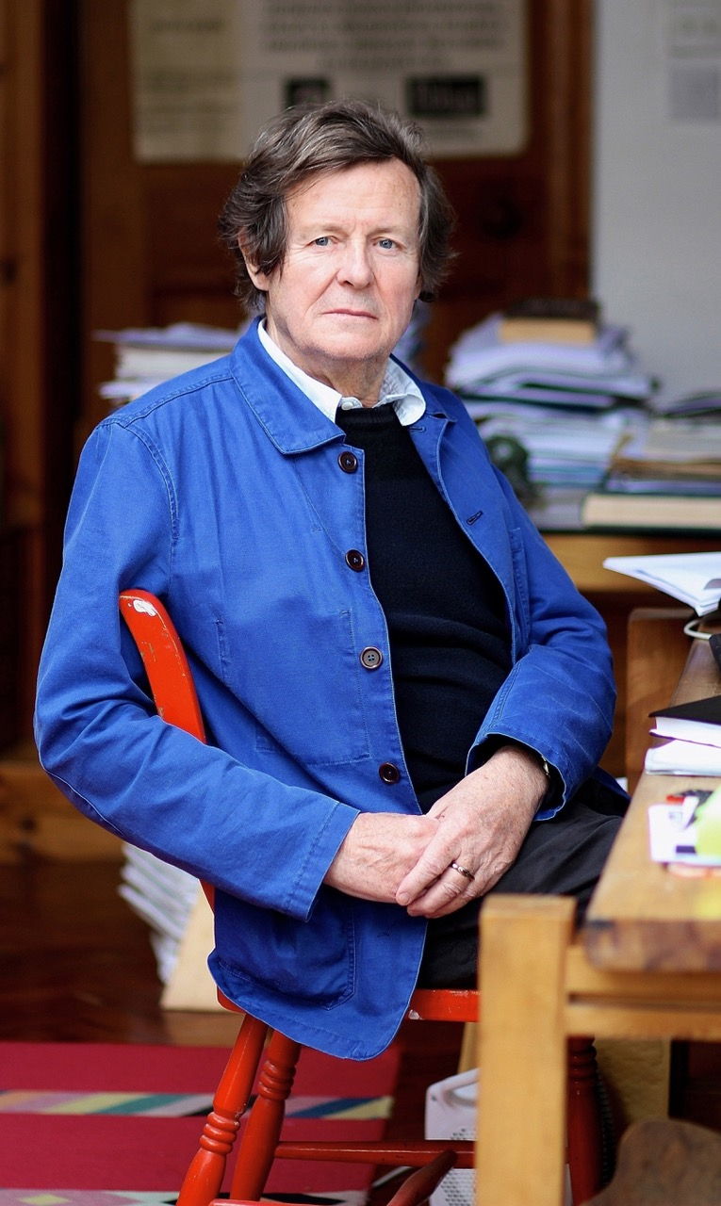
Described by The Washington Post as ‘the premiere political dramatist writing in English’, the festival is truly honoured to be featuring the BAFTA-winning playwright David Hare, who will take part in the inaugural ‘Tom Stoppard Conversation’ in honour of the great British playwright and screenwriter who died in 2025. Tom Stoppard’s connection to Chalke was both personal and enduring. Following his death last year, and with the support of his wife Sabrina Guinness, the festival is proud to honour his legacy with a new annual ‘Conversation’ celebrating the history of theatre. In this inaugural event, David Hare will reflect on Stoppard’s remarkable life and work and will share insights from a fifty-year friendship with his ‘confrère’. It will be an intimate and illuminating tribute to one of the great voices of modern theatre.
(Photo of David Hare, credit Walter van Dyk)
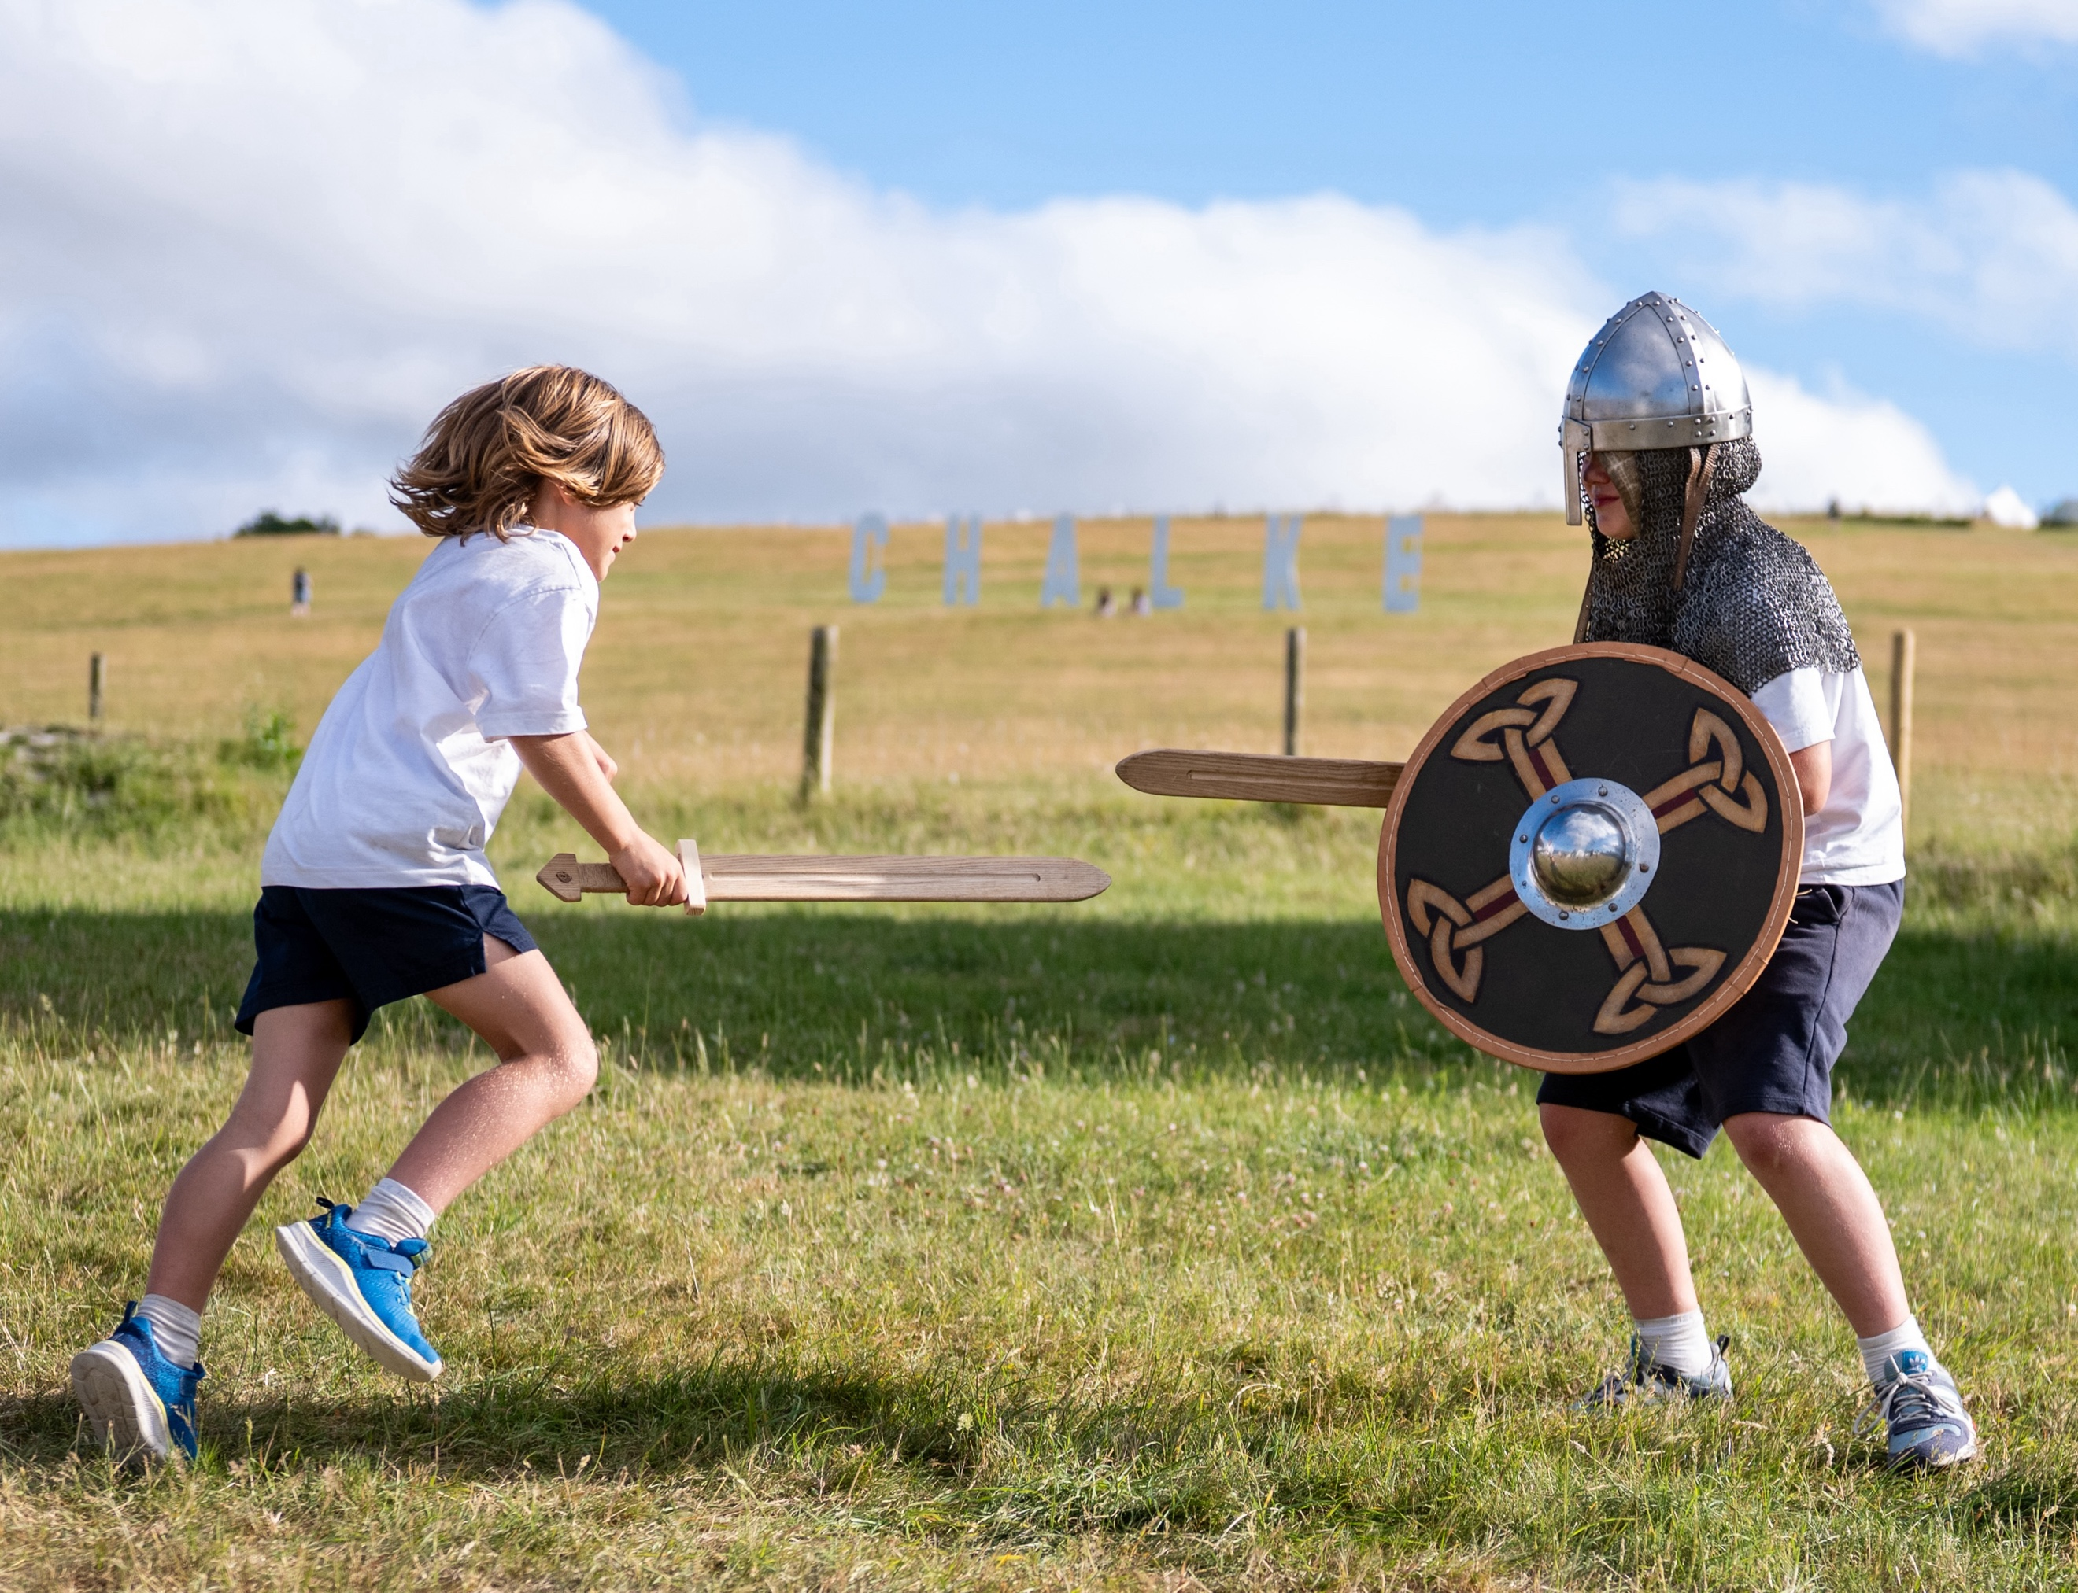
Elsewhere on the festival site, visitors will have a feast of different activities and workshops to choose from. As well as the reconstruction of a magnificent late Iron Age Romano-British chariot by a team of artisans using ancient techniques, Abs Wisdom returns with his Wizzo’s Rip-Roaring History old-time circus sideshow and a series of hilarious, informative and educational performances that will delight and involve all the family. For those who want to learn more about the Viking Age, including storytelling, arms and armour, and how textiles and clothes were dyed in those times, then The Castle Hill Heritage Skills group will be sharing their expert knowledge on the subject. There will be plenty of activities to keep the kids entertained too, including: the Rattlebox Theatre and Angel Heart Theatre with their blend of puppetry, storytelling and larger-than-life characters; historic garden games like sack races, rolling hoops, skittles, and croquet; plus, interactive workshops offering tablet weaving and medieval calligraphy, and a chance for the little ones to try their hand at sword-fighting, archery, or axe-throwing.

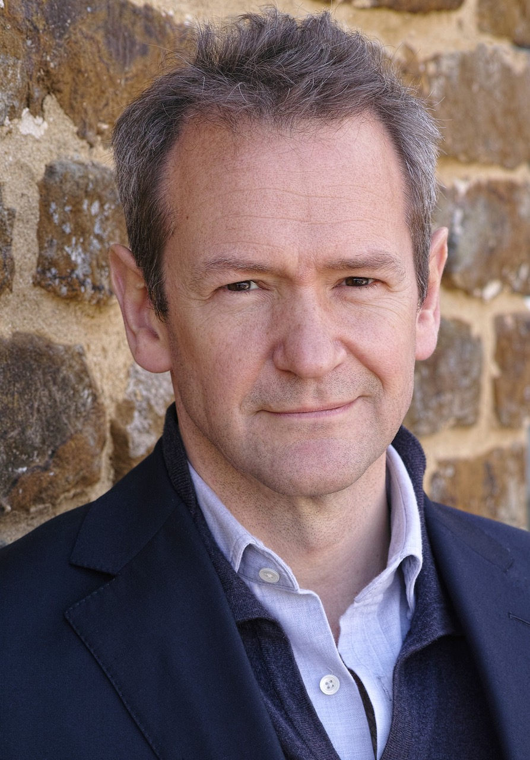
An eclectic mix of preferences and interests means that, although the lineup always needs to reflect current concerns about global affairs, it also has to satisfy a desire by many to know more about social history, the ancient world, the thrill of exploration or the history of British farming. The 2026 programme therefore reflects this with something for everyone in the wide variety of talks and discussions on offer. Actor, comedian and broadcaster Alexander Armstrong will be talking about the cultural influence of Marie Antoinette, wife of Louis XVI and last Queen of France before the French Revolution; former Venezuelan opposition leader Leopoldo Lopez will be asking the sticky question of how you unseat a dictator with Ugandan activist, politician, and singer Bobi Wine; documentary presenter and the actor best known for playing Baldrick in BBC TV’s Blackadder Tony Robinson will be presenting his adult fiction debut novel, set in the world of the Anglo-Saxons, The House of Wolf; adventurer Lucy Shepherd will discuss what it means to be an explorer in the 21st century; winner of the 2025 Cundill History Prize Lyndal Roper will talk about the German Peasants’ revolt with Afua Hirsch; Henry Montgomery, grandson of Field Marshall Montgomery (Monty) will consider whether Britain’s remembrance culture is working; Paul Cartledge will take to the stage with Tom Holland to discuss Pericles; and the presenter of R4’s In Our Time Misha Glenny will come together with his producer Miles Warde to give a talk based on their long-running and hugely popular BBC radio series How To Invent a Country. (Photo of Alexander Armstrong by Jonny Ring)

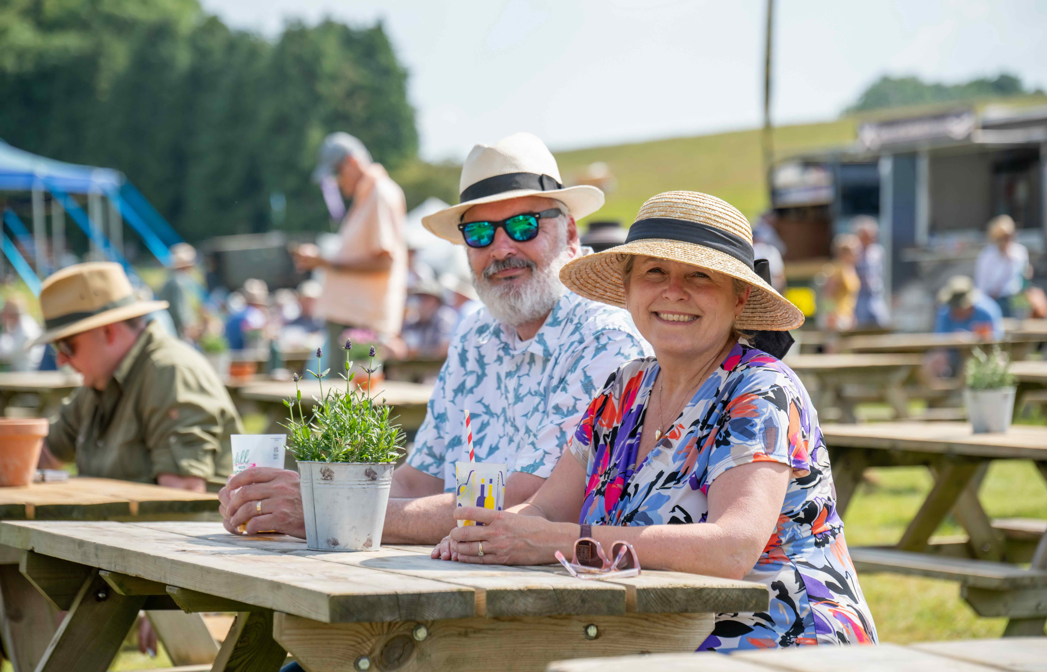
Refreshments by the bar at Chalke, credit Martin Cooke

Chalke would not be Chalke without that little bit ‘extra’ that makes the festival so special. From exquisite meals in the fine dining tent, mouth-watering local produce, street food and ice creams, thirst-quenching drinks at the Chalke Valley Tap, to vintage clothing and jewellery in the Emporium, plus a chance to meet favourite authors at the Waterstones book signings, the festival promises a truly wonderful day out. And it doesn’t stop there. The midsummer evenings provide a chance to swap ideas with fellow history buffs over a glass of something chilled by the firepit or dance the night away to ABBA’s Angels or The Brass Funkeys. Those who choose to glamp or camp under the stars will be glad the commute home is only up the hill, a matter of minutes away.

The Chalke History Festival for Schools runs from Monday 22nd June to Wednesday 24th June, with the Wednesday being solely a SEND day for all school ages. Further information and details on how to book can be found on the festival website here which includes the programme and a list of activities arranged for each day.

The Chalke History Festival will take place at Church Bottom, Broad Chalke, Salisbury, Wiltshire, SP5 5DP. For more details about the festival, please visit our website at www.chalkefestival.com Follow all the news on X at @ChalkeFestival, on Instagram at @chalkehistoryfestival, on Facebook and on LinkedIn.

About the Chalke History Festival

Attracting the finest and most distinguished historians, academics, leading thinkers, and writers from the UK and abroad, the Chalke History Festival is now firmly established as one of the must-attend events of the festival summer. Taking place on a 70-acre farm, in the heart of the Wessex countryside just outside Salisbury in Wiltshire, it blends inspiring literary talks, discussions and panels with eye-catching and entertaining living history and historical experiences.

About Evelyn Partners
Evelyn Partners is a leading wealth management group, created through the merger of Tilney and Smith & Williamson in 2020, with a rich heritage of supporting individuals, families, and charities with the financial affairs for 189 years. With £67.0 billion of assets under management (as at 30 September 2025), we are one of the largest UK wealth managers ranked by client assets.

Through an extensive network of offices in 21 towns and cities in the UK, as well as the Republic of Ireland and the Channel Islands, we support private clients, family trusts, and charities, as well as provide investment solutions to financial intermediaries. Our diverse client base includes entrepreneurs, C-suite executives, partners of professional firms and sports professionals.

Our expertise spans both award-winning financial planning and investment management, enabling us to offer clients a truly holistic total wealth management service. Through Bestinvest, we also provide an online investment platform and coaching service for self-directed investors, consistent with our purpose of ‘placing the power of good advice into more hands’.

