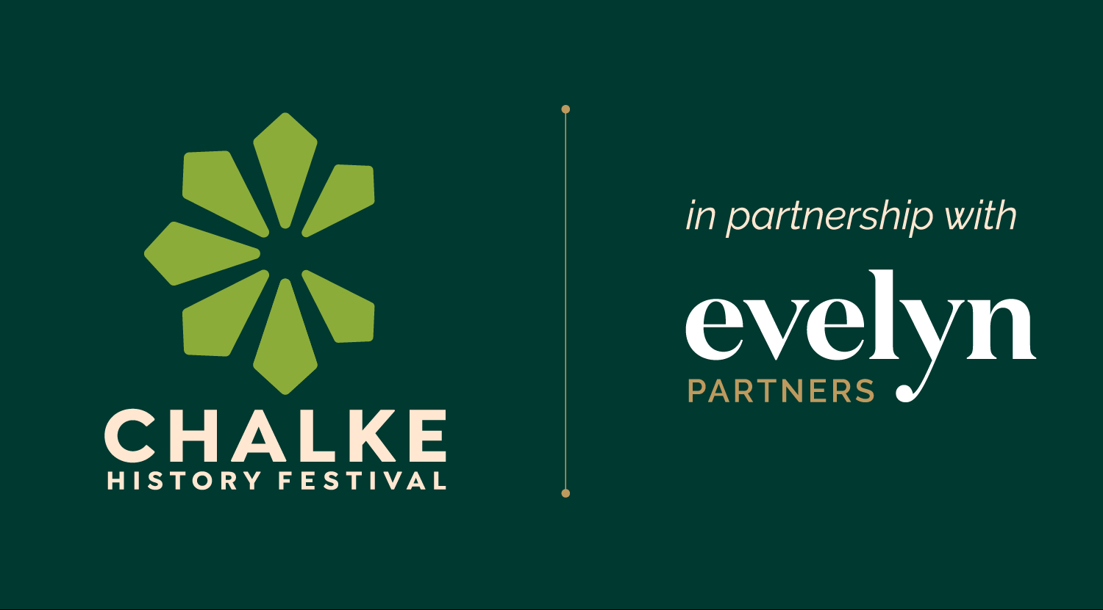

Chalke History Festival: 22nd to 28th June 2026

Chalke Introduces: the next generation of talent making its
mark on history

Film at Chalke: Oscar-winning filmmaker Mstyslav Chernov/
new Chalke Cinema to show a wide range of thematic movies

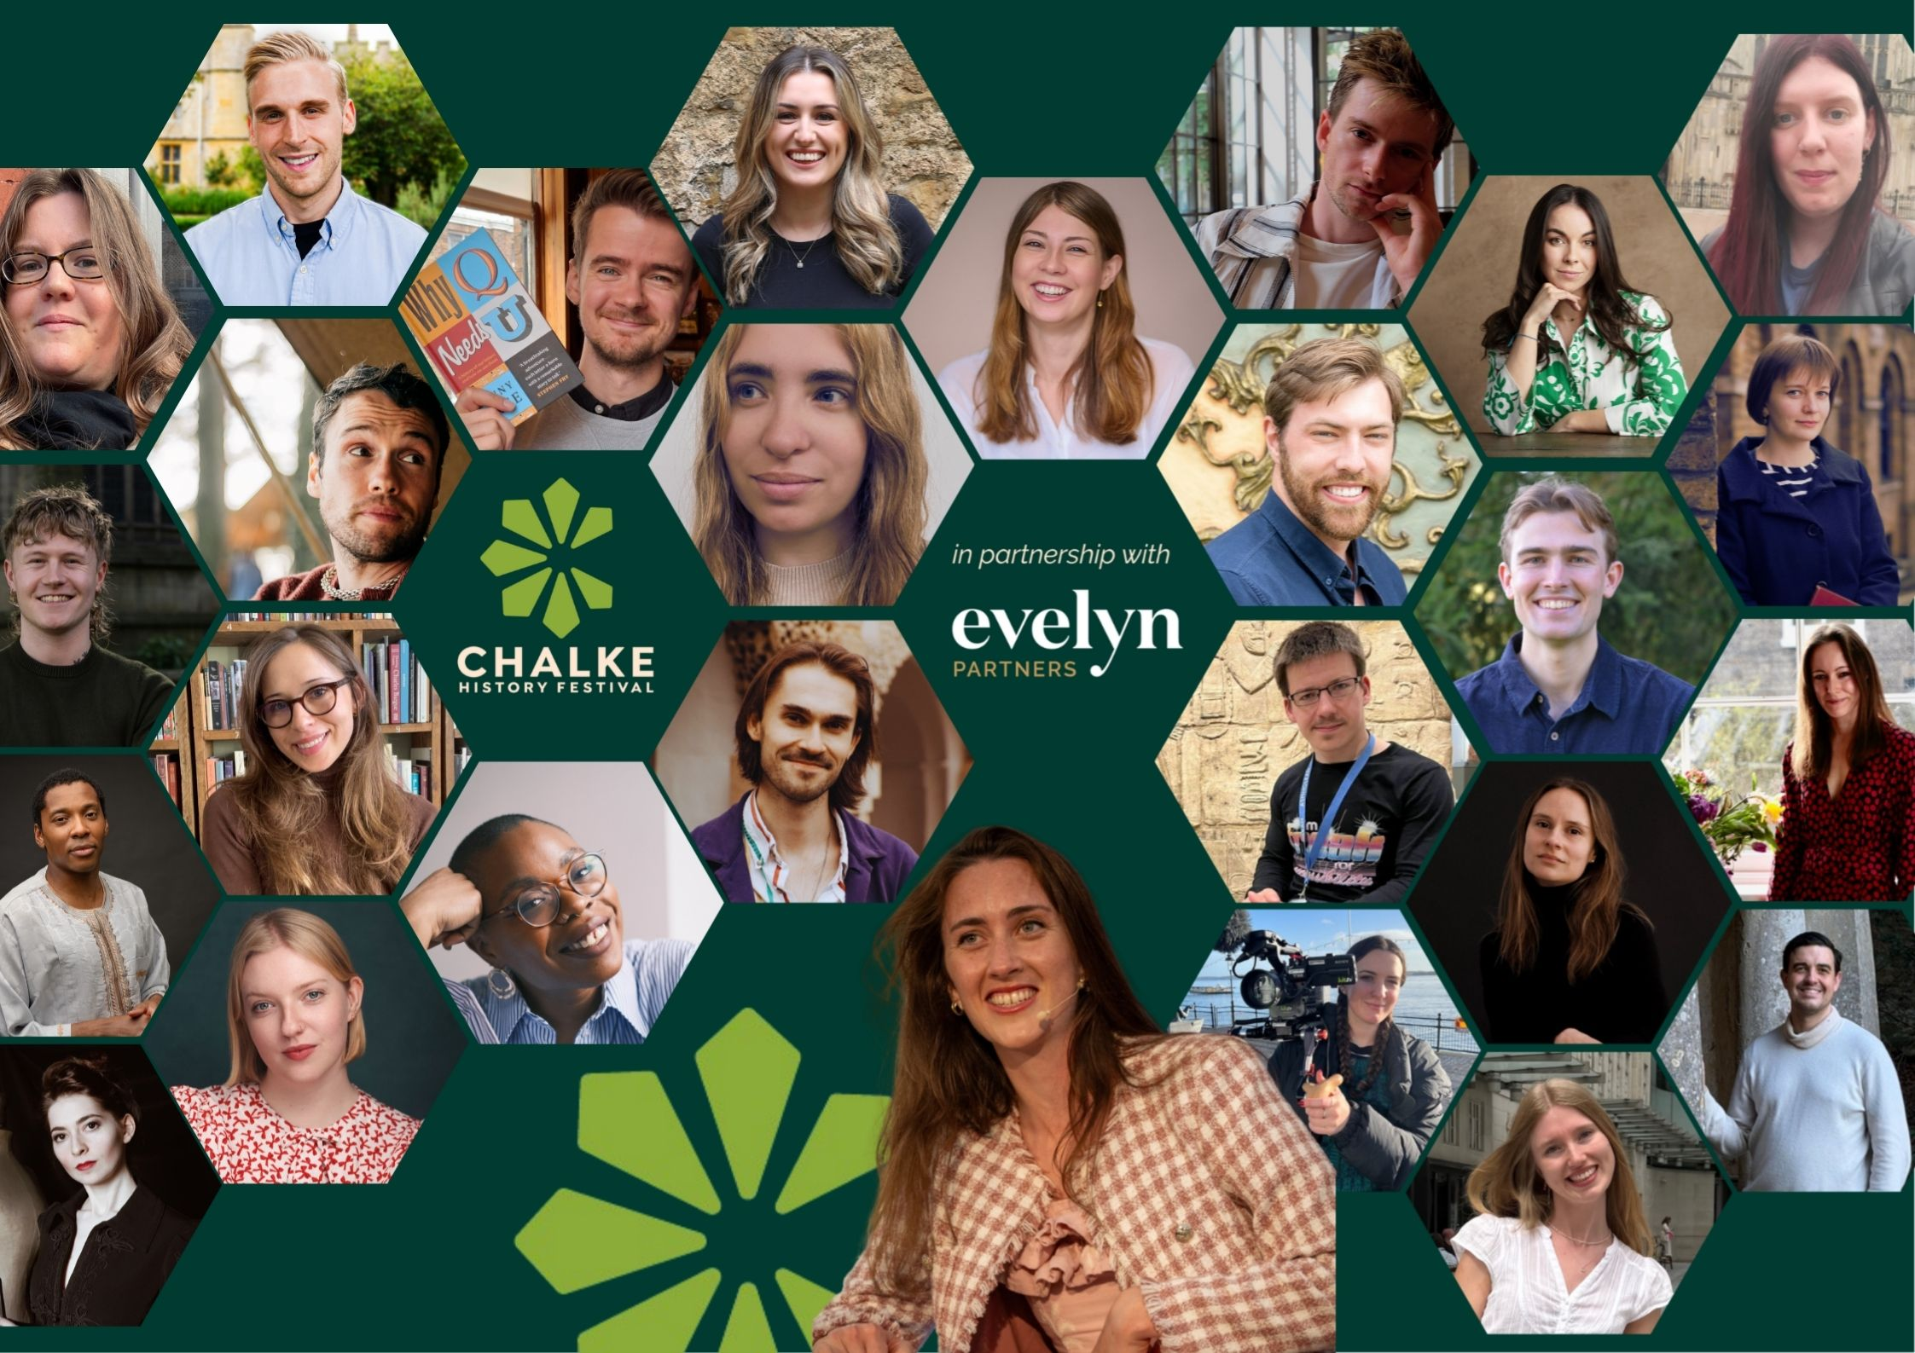
Chalke Introduces 2026

With less than two weeks to go before the start of the Chalke History Festival, final preparations are being put into place for the biggest historical extravaganza of the year. An extraordinary lineup of VIPs, experts and thought leaders await, alongside some of the most exciting performers, living historians, and musicians in the land. Whether it’s a talk about the road to war in the 1930s with Anthony Scaramucci and James Holland that takes your fancy, or a performance of ‘The Tragedie of Macbeth’ as the sun goes down, there will be something for all the family. As well as a plethora of household names, there will also be chance to discover some new voices and to find out about how a whole new wave of innovators are sharing history in very different ways.

Following the success of last year’s inaugural programme, Chalke Introduces 2026 brings together some of the most exciting young historians and history communicators working today, offering fresh perspectives on everything from medieval queens and Tudor intrigue to disability history, queer history, art, fashion, and folklore. Across talks, panels, and live discussions, these speakers combine rigorous research with accessible storytelling, making complex histories vivid, engaging, and deeply relevant. The programme highlights a new generation of historians who are reshaping how history is shared with wider audiences through social media, public history, performance, and interdisciplinary research. The lineup includes Breeze Barrington, Luke Pepera, Hetta Howes, Harry Tanner, Kate McCaffrey, George Fouracres (on the Histrionics panel) and Verity Babbs.
Current affairs and exclusive geopolitical debate are never too far off the agenda at Chalke and, given what is currently happening around the world, this June is no exception. On Friday morning, The Telegraph team behind Ukraine: The Latest, the world’s most listened-to and award-winning podcast on the war in Ukraine, returns. This highly topical event, with Francis Dearnley, Dominic Nicholls and Adélie Pojzman-Pontay will give the audience a unique insight into the most up-to-date news from the front line. Elsewhere, Iran, the US and the politics of oil may also be dominating the headlines, but this story has been unfolding for decades. In a special event on Friday night , Ali Ansari, Ben Hodges and Helen Thompson bring their combined expertise in global politics, warfare and energy security to unravel the deeper history behind the current tensions in Iran and elsewhere.

While all eyes are currently on conflict in the Middle East, tensions are also escalating in the Indo-Pacific. In this timely Friday panel, leading experts on the region – including Franco Algieri, Tomonori Yoshizaki and Chairman of The Alphen Group Julian Lindley-French – will examine China’s growing influence and ambitions towards Tawain, and the complex relationships between China, Japan, India and the United States. They will also ask ‘What would conflict in the Indo-Pacific mean for global trade, security and stability?’ And on Saturday an authoritative panel of senior generals – Rob Bertholee, Richard Shirreff, Mick Ryan, David Richards and Ben Hodges - will assemble for a vital discussion about the military situation in which we now find ourselves, the threats we face, and our preparedness to confront those threats in a rapidly changing world. This will be a unique opportunity to hear their take on whether or not Britain and Europe are ready for conflict.

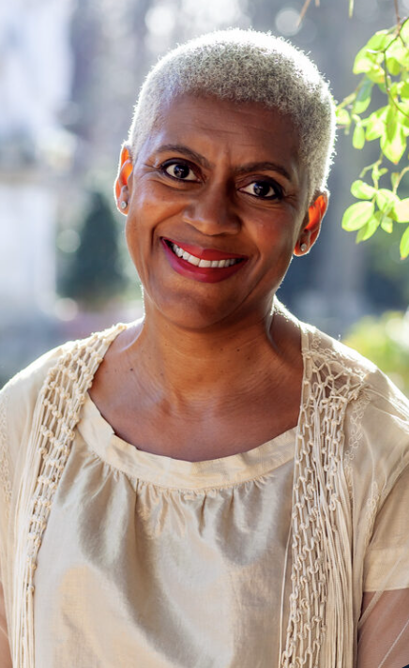
Hot off the back of their recent appearances at the Chelsea Flower Show, where they graced our TV screens and brought us all the latest botanical news from world’s most prestigious gardening event, celebrated gardener and broadcaster Alan Titchmarsh and horticulturalist and designer Arit Anderson will be together again at Chalke celebrating the National Garden Scheme which marks its centenary in 2027, along with historian and author George Plumptre. Former President of the National Farmers’ Union of England and Wales Minette Batters will bring her powerful and personal perspective on agriculture today to a talk about the harvest and farming, as she explores food security, rural life and what it takes to feed the nation with historian and presenter Alex Langlands. Continuing the countryside theme, archaeologist Eloise Kane will be asking the questions ‘When was Britain last truly wild?’, ‘What does wild actually mean?’, and ‘What role do we play in Britain’s ecological future?’. (Photo of Arit Anderson)

Popcorn and locally sourced hot dogs will be the order of the day as visitors can, for the first time this year, relax in the new Chalke Cinema from the Wednesday onwards. The tent will be showing a wide range of movies based on a number of different themes such as Shakespeare, the land and sea, and WW2. The festival is also very honoured to be welcoming Oscar-winning filmmaker Mstyslav Chernov who will be sharing his journey documenting the siege of Mariupol, reporting from the heart of Ukraine’s war, and witnessing history unfold firsthand. Winner of the 2024 Oscar for Best International Feature for 20 Days in Mariupol, Chernov will offer a powerful insight into the moral complexities of reporting war in his own country and will explore the role of filmmaking in shaping understanding, bearing witness, and creating the first draft of history.
If travel and adventure is your bag, Lucy Shepherd will be discussing what it means to be an explorer in the twenty-first century as she shares remarkable stories of her latest expedition into the heart of the Amazon rainforest and the faraway Kanuku Mountains of Guyana. Continuing with the theme of human endurance Hugo and Ross Turner – aka the Turner Twins – will be sharing the story of their journey to reimagine George Mallory and Sandy Irvine’s attempt to reach the summit of Everest in 1924. The twins climbed Mera Peak, Nepal’s highest trekking mountain, one wearing a faithful replica of the 1924 expedition gear, the other decked out in the latest high-altitude technology. All three will be speaking with award-winning documentary maker and broadcaster Alex Bescoby.

The Cecil Sharp House Choir is known for its spirited and moving renditions of traditional songs and is making its debut at Chalke this June. Run by the English Folk Dance and Song Society, and led by Rose Martin, the Choir concentrates on singing acapella folk and traditional songs from Britain and beyond. Previous performances include Trafalgar Square, the Southbank Centre, the National Maritime Museum, Oslo Musikkfest, Sidmouth Folk Festival and the House of Commons. Booked for midday on the Sunday, the Choir is bound to be a highlight for the lunchtime crowds.

Espionage, undercover assassinations and deadly agents also form a strong theme at this year’s festival. Historian Antonia Senior and spy thriller writer Charles Cumming will be uncovering the chilling true story of the Cambridge Five, the brilliant young spies who betrayed Britain to Stalin after being radicalised at Cambridge in the 1930s. Drawing on newly uncovered intelligence and centuries of conflict, Nigel West and Paul Beaver will be talking about exploding cigars and blades in the dark as they uncover how assassination tactics evolve yet remain rooted in the same enduring struggle for control, influence, and survival at the highest levels of power. Plus, Gordon Corera and John Tregoning will be having a gripping discussion about the history, science, and covert operations behind biological and chemical weapons as they follow the chilling journey from the conventional battlefield into the hidden world of espionage.

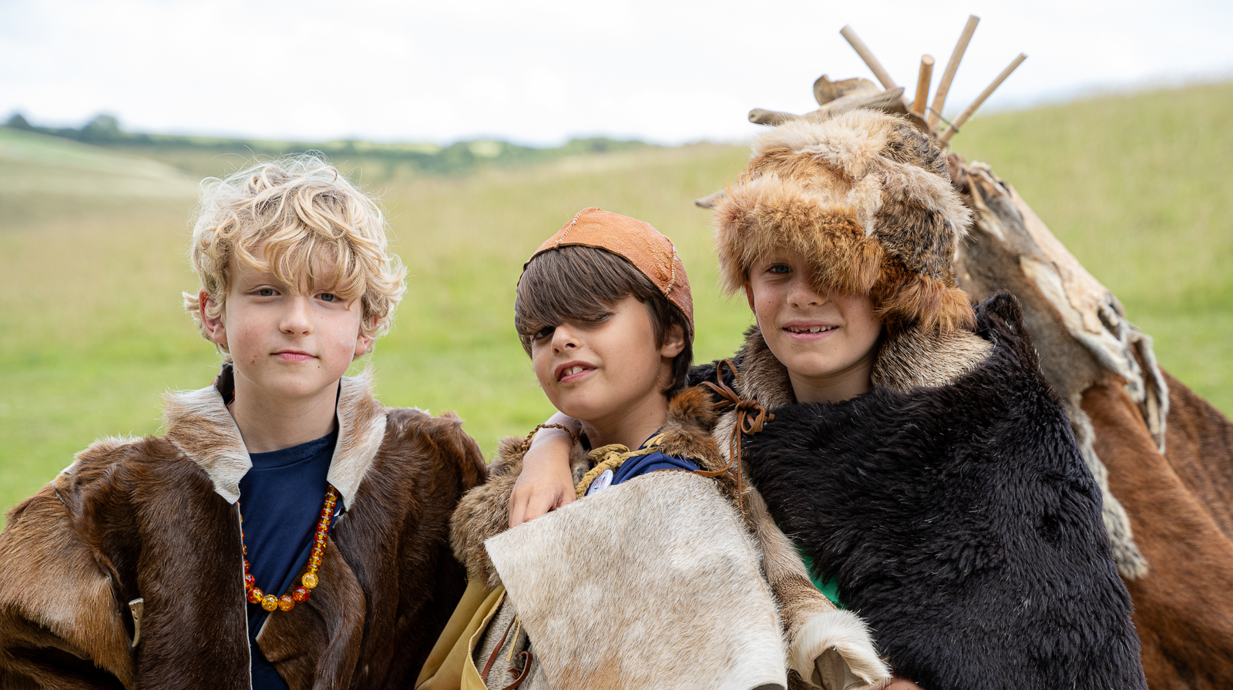
Kids dressing up at Chalke - photo credit: Graham Smith

There will be lots to keep the little ones busy at this year’s festival, with professional artist and costumier Tabitha Grove overseeing a Family Craft Tent full of engaging activities on the Friday, Saturday and Sunday. Kids will have the opportunity to craft their own Shakespearean Ruff, to design a silly Roman face pot and to get all tied up in Celtic knots. Elsewhere, a range of fun and interactive events - like listening to storytellers tell tales about life in prehistory, learning how pots were shaped in the Iron Age and how food was prepared in Ancient Pompeii - will both delight and educate all members of the family, whatever age you are. All children aged 15 and under get free entry to the festival with an accompanying paying adult.

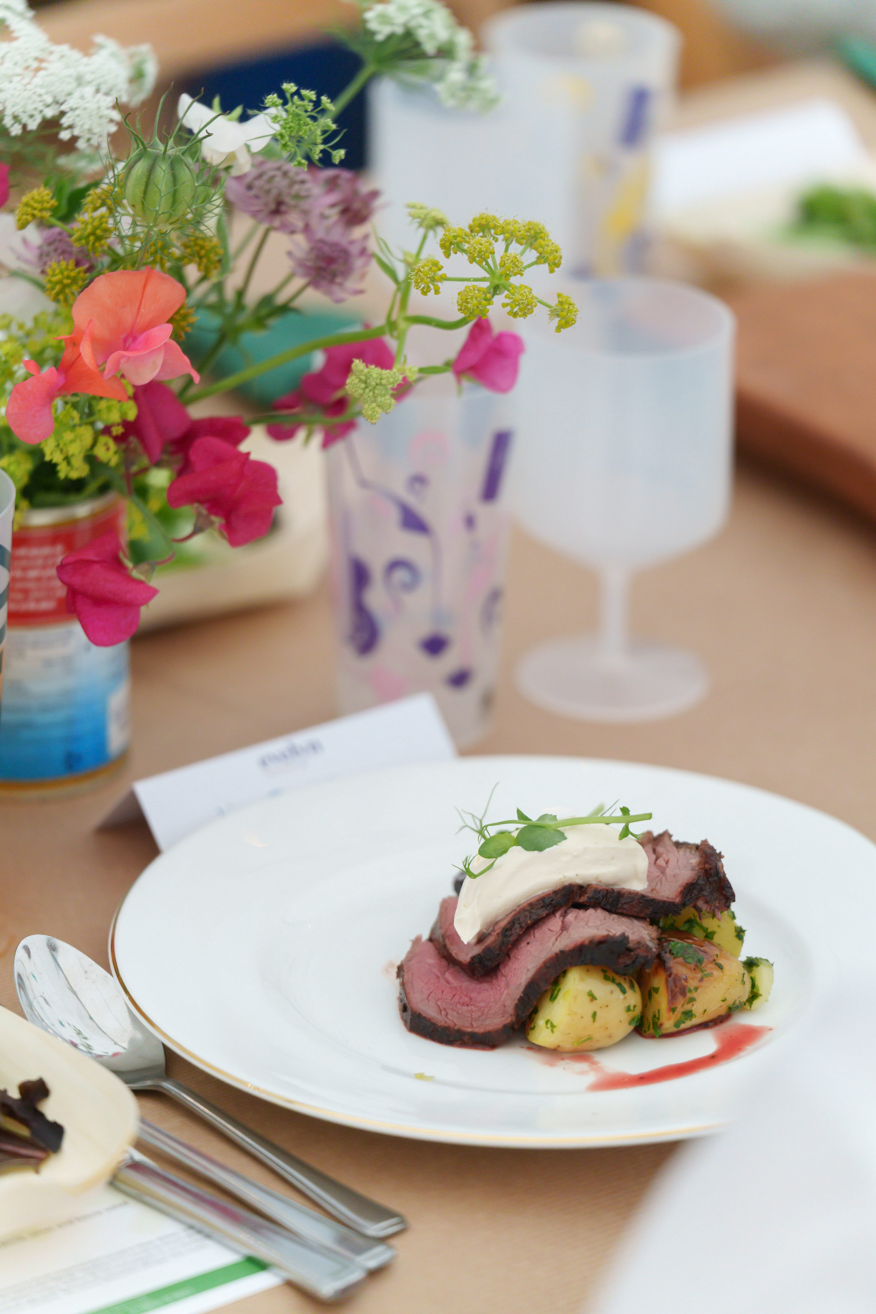
The Fine Dining Experience is always a real treat for visitors and this year there will be not one but two renowned cooks serving up mouth-watering meals throughout the week. Victoria Blashford-Snell returns from Monday to Thursday, crafting a delicious new menu each day and using only the freshest, local sourced ingredients. Then from Friday to Sunday, for the first time at Chalke, Becka Cooper (best known for her food at The Grange Festival) and her team will be tempting everyone’s taste buds with a delicious menu of local, seasonal, field-to-fork meals. For those wishing to browse menus and to book places, should visit here. (Photo: Ash Mills)

The Chalke History Festival will take place at Church Bottom, Broad Chalke, Salisbury, Wiltshire, SP5 5DP. For tickets and more details, please visit our website at www.chalkefestival.com Follow all the news on X at @ChalkeFestival, on Instagram at @chalkehistoryfestival, on Facebook and on LinkedIn.

About the Chalke History Festival

Attracting the finest and most distinguished historians, academics, leading thinkers, and writers from the UK and abroad, the Chalke History Festival is now firmly established as one of the must-attend events of the festival summer. Taking place on a 70-acre farm, in the heart of the Wessex countryside just outside Salisbury in Wiltshire, it blends inspiring literary talks, discussions and panels with eye-catching and entertaining living history and historical experiences.

About Evelyn Partners
Evelyn Partners is a leading wealth management group, created through the merger of Tilney and Smith & Williamson in 2020, with a rich heritage of supporting individuals, families, and charities with the financial affairs for 189 years. With £67.0 billion of assets under management (as at 30 September 2025), we are one of the largest UK wealth managers ranked by client assets.

Through an extensive network of offices in 21 towns and cities in the UK, as well as the Republic of Ireland and the Channel Islands, we support private clients, family trusts, and charities, as well as provide investment solutions to financial intermediaries. Our diverse client base includes entrepreneurs, C-suite executives, partners of professional firms and sports professionals.

Our expertise spans both award-winning financial planning and investment management, enabling us to offer clients a truly holistic total wealth management service. Through Bestinvest, we also provide an online investment platform and coaching service for self-directed investors, consistent with our purpose of ‘placing the power of good advice into more hands’.

